**CRMApplicationforJewelManagement**

**College Name:** Nandha Arts Science College

**College Code:** bru4j

**TEAMID:** NM2025TMID23175

**TEAMMEMBERS:**

**TeamLeaderName :**AADHIL IRFAN A

**Email**:iaadhil467@gmail.com

**TeamMember1**:ANITHA K

**Email:**anithaakumaresan@gmail.com

**TeamMember**:ARUN KARTHICK K

**Email:** kumargeetha@gmail.com

**TeamMember:**BHARATH BALAJI G

**Email**:bharathgiri7755@gmail.com

CRMApplicationforJewelManagement

**UsingSalesforce**…

## **Project Overview :**

TheCRMApplicationforJewelManagementisasoftwaresolutiondesignedtohelpjewelry businessesefficientlymanagetheircustomers,inventory,sales,andservices.Unlike genericCRMsystems,thisapplicationfocusesonthespecificneedsofjewelers,suchas trackingjewelryitemsbykarat,weight,stonetype,andcertification,whilealsomaintaining strong customer relationships.

Thesystemprovidesacentralizedplatformwherejewelerscan: Storeandmanagedetailedcustomerinformation.

Trackinventoryofgold,silver,diamond,andplatinumjewelry. Handlebilling,invoices,repairs,andreturns.

Generateinsightsandsalesreportsforbusinessdecisions.

Improvecustomerloyaltythroughpersonalizedoffersandreminders.

Byautomatingroutinetasksandofferinganalytics,theapplicationreducesmanualwork, increasesaccuracyinbillingandinventory,andsupportstargetedmarketingcampaigns.It benefitsbothsmalljewelshopsandmulti-branchjewelrychainsbystreamlining operationsandenhancingcustomersatisfaction.

**Objectives**:

1. CustomerRelationshipManagement–Maintaindetailedcustomerprofiles includingpurchasehistory,preferences,andloyaltypointstobuildlong-term relationships.
2. EfficientInventoryControl–Trackjewelryitemsbasedonkarat,weight,stonetype, andcertification,withreal-timestockupdatesandlow-stockalerts.
3. SalesCBillingAutomation–GenerateaccurateinvoiceswithGST/taxcalculations, discounts,andinstallmentoptions,reducingmanualerrors.
4. OrderCRepairManagement–Managecustomjewelryorders,repairrequests, returns, and exchanges seamlessly.
5. AnalyticsCReporting–Providebusinessinsightsthroughsalesreports,profit analysis,andcustomerbehaviortrackingforbetterdecision-making.
6. MarketingCNotifications–Sendpersonalizedoffers,festivalgreetings,and reminders(birthdays/anniversaries)viaSMS/Emailtoimprovecustomer engagement.
7. SecurityCUserRoles–Ensuresecureaccessthroughauthenticationandassign role-basedpermissions(Admin,SalesExecutive,Accountant).
8. Multi-BranchSupport –Allowcentralizedmanagementforjewelrybusinesses operating across multiple branches.

# Student Outcomes :

1. PracticalApplicationofCRMConcepts–GainedknowledgeonhowCRMsystems workinreal-worldindustries,especiallyinthejewelrydomain.
2. SystemDesignCDevelopmentSkills–Learnedhowtoanalyzerequirements, designERdiagrams,anddevelopmoduleslikecustomer,inventory,sales,and billingmanagement.
3. Technical SkillsEnhancement –Improvedskillsinfrontend(React/Angular/Flutter), backend(Node.js/Django),database(MySQL/PostgreSQL),andAPIintegration.
4. Problem-SolvingAbility–Appliedlogicalthinkingtosolvechallengeslikeinventory tracking,ordermanagement,andsecurebilling.
5. TeamCollaborationCProjectManagement–Experiencedworkingasateam, dividingmodules,usingversioncontrol(GitHub),andfollowingSDLCstages.
6. DataHandlingCAnalytics–Learnedhowtogenerateandanalyzesales/customer reports for decision-making.
7. Real-World Business Understanding –Understood jewelrybusiness processes (karat/weighttracking,repairs,loyaltyprograms)andtranslatedthemintosoftware solutions.
8. ProfessionalPresentation–Enhancedabilitytodocument,present,and demonstrateacompleteprojecttoevaluatorsandindustryprofessionals

**SystemRequirements:**

HardwareRequirements:

* + Computerwithmin/sum4GBRAM,Dual-coreprocessor
  + Stableinternetconnection

SoftwareRequirements:

* + SalesforceDeveloperEditionOrg
  + ModernWebBrowser(e.g.,GoogleChrome,Firefox)

## **Project Duration :**

31Hours

**PhasesOverview:**

**PhaseNo.**

**PhaseNameDescriptionPageNumbers**

1. Requirement AnalysisCPlanning

Gathering requirementsfrom donors,volunteers,andreceivers; definingscopeandgoals;planning data model and workflows.

1. Salesforce Development– BackendC Configurations

Creatingcustomobjects,fields, relationships;settingupFlows andApexTriggersfor automation.

4-11

1. UI/UXDevelopment CCustomization BuildingLightningApp,

customizinglayouts,addingfields, implementing Flows, and developing UI logic.

11-28

1. DataMigration, TestingCSecurity

CreatingUsers,Profiles,Public Groups, Sharing Rules;

configuringReportTypes,Reports,Dashboards;testingfunctionalitiesandensuringdata security.

28-37

1. Deployment, DocumentationC Maintenance

Designing and finalizing Home Page,deployingsolutiontolive environment,preparing documentation,conclusion,and ongoing system maintenance.

37–40

## **Phase1:RequirementAnalysissPlanning:-**

**CRMApplicationforJewelManagement-(Developer)**

The JewelInventory System is a comprehensive software Solution designed to streamline and manage the inventory and sales processes of a jewellery store or a jewellery manufacturer. The systemaimstoprovide anefficientanduser-friendlysolutiontotrackandcontroltheinventoryof various jewellery items, maintain accurate records, and facilitate seamless sales transactions.

##### **Whatyou'lllearn**

* 1. RealTimeSalesforceProject
  2. DataModelling
  3. CreatinganApplication
  4. UserInterfaceCustomization
  5. Object&RelationshipinSalesforce
  6. FormulafieldsandValidationrules.
  7. FieldDependencies
  8. Record Types
  9. Crossobjectformulafields.
  10. Conditionalformatting.
  11. Flows
  12. Emailalertsandemailtemplates
  13. Reports&Dashboards

## **Phase2:SalesforceDevelopment–BackendsConfigurations:-**

**Milestone1:Salesforce**

**Introduction:**

AreyounewtoSalesforce?Notsureexactlywhatitis,orhowtouseit?Don’t knowwhereyou should startonyourlearningjourney?Ifyou’ve answered yestoanyofthese questions,then you’re in the right place. This module is for you.

WelcometoSalesforce!Salesforceisgame-changingtechnology,withahostofproductivity- boostingfeatures,thatwillhelpyousellsmarterandfaster.Asyouworktowardyourbadge for this module, we’ll take you through these features and answer the question, “What is Salesforce,anyway?”.

**WhatIsSalesforce?**

Salesforceisyourcustomersuccessplatform,designedtohelpyousell,service,market, analyze, and connect with your customers.

Salesforce has everything you need to run your business from anywhere. Using standard products and features, you can manage relationships with prospects and customers, collaborate and engage withemployeesand partners,and store yourdatasecurelyinthe cloud.

Sowhatdoesthatreallymean?Well,beforeSalesforce,yourcontacts,emails,follow-uptasks, and prospective deals might have been organised something like this: <https://youtu.be/r9EX3lGde5k>

Activity1:CreatingDeveloperAccount

**Creatingadeveloperorginsalesforce.**

1. Goto<https://developer.salesforce.com/signup>
2. Onthesignupform,enterthefollowingdetails:

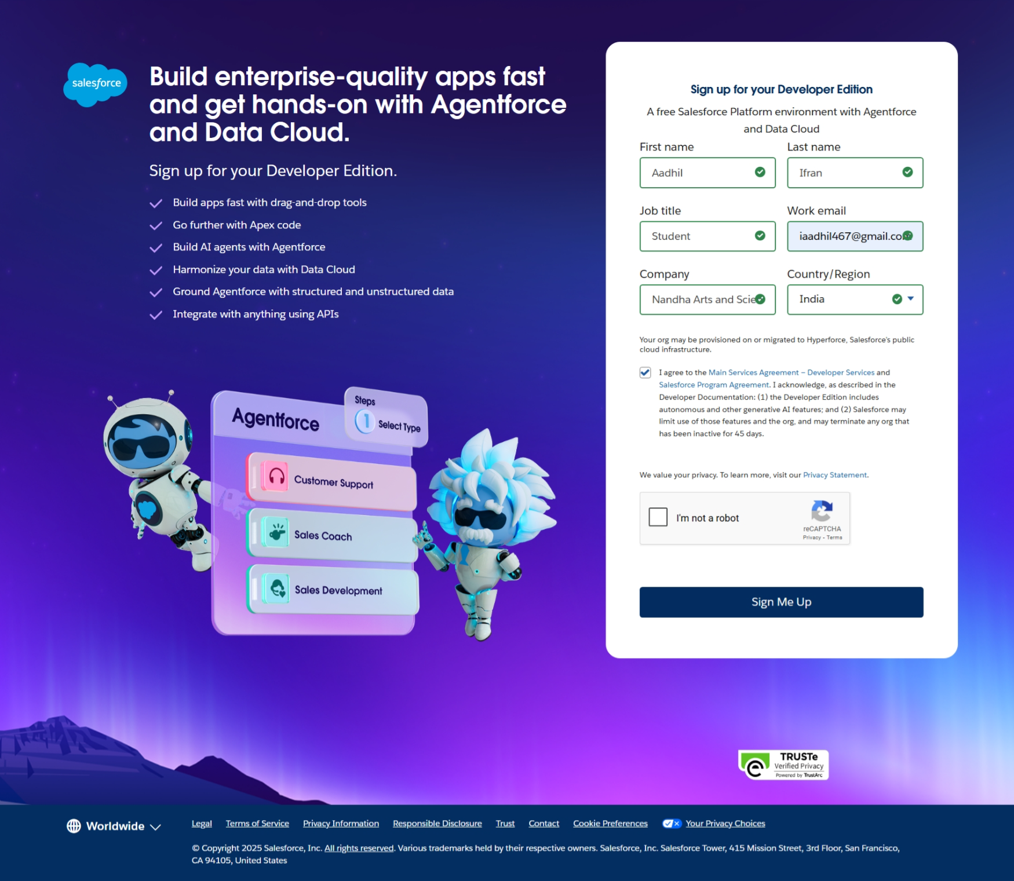

* 1. Firstname&Lastname
  2. Email
  3. Role:Developer
  4. Company:CollegeName
  5. County:India
  6. PostalCode:pincode
  7. Username:shouldbeacombinationofyournameandcompany

Thisneednotbeanactualemailid,youcangiveanythingintheformat:[username@organization.com](mailto:username@organization.com)

Clickonsignmeupafterfillingthese.

Activity2:AccountActivation

1. Gototheinboxoftheemailthatyouusedwhilesigningup.Clickontheverify accounttoactivateyouraccount.Theemailmaytake 5-10mins.

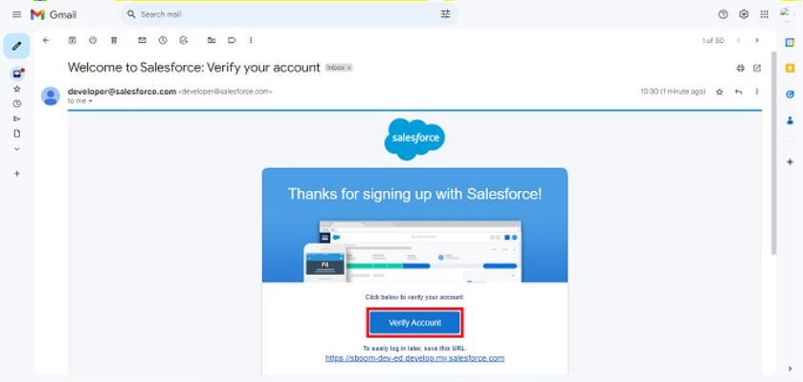

1. ClickonVerifyAccount
2. Giveapasswordandanswerasecurityquestionandclickonchangepassword.

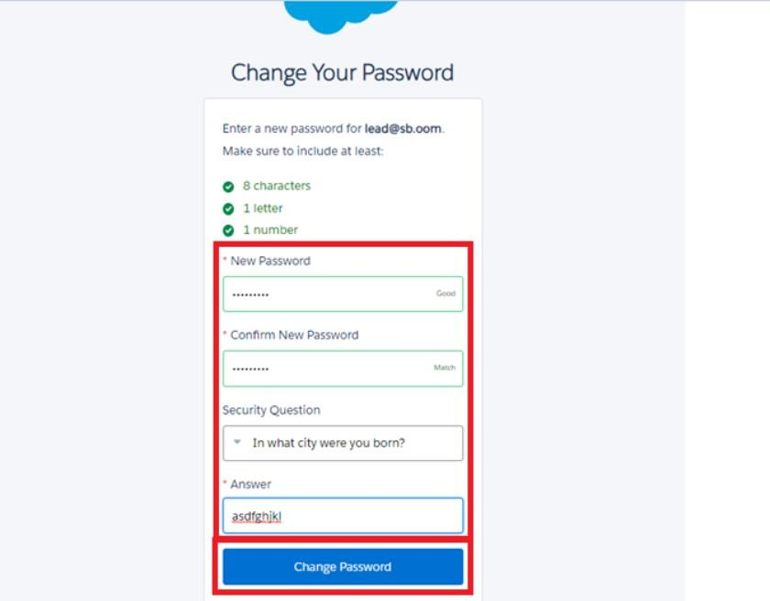

1. Thenyouwillredirecttoyoursalesforcesetuppage.

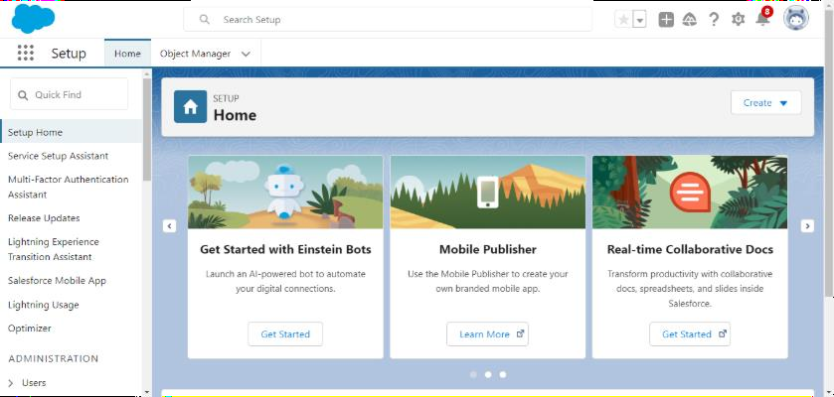

# **Milestone2:Object**

##### **WhatIsanObject?**

Salesforceobjectsaredatabasetablesthatpermityou tostoredatathatisspecifictoan organization. What are the types of Salesforce objects

Salesforceobjectsareof twotypes:

1. StandardObjects:Standardobjectsarethekindofobjectsthatareprovidedby salesforce.comsuchasusers,contracts,reports,dashboards,etc.
2. CustomObjects:Customobjectsarethoseobjectsthatarecreatedbyusers.They supplyinformationthatisuniqueandessentialtotheirorganization.Theyarethe heart ofany applicationand providea structurefor sharing data.

## **UseCase:**

CreatinganobjectinSalesforceorganisationisessentialforefficientdatamanagementandprocess automation. By defining custom objects, businesses can structure and store data specific to their needs, enabling streamlined workflows, personalized reporting, and enhanced user experiences.

ObjectsserveasthefoundationfororganizingandleveragingcriticalinformationwithinSalesforce. To Navigate to Setup page:

Clickongearicon>>clicksetup.

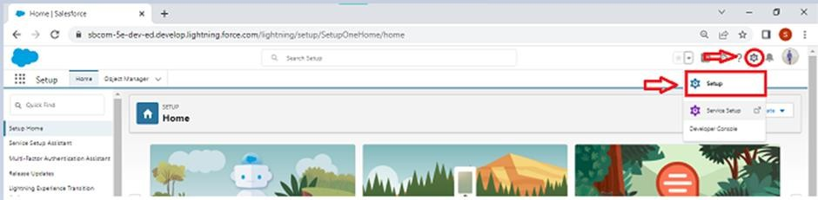

**Activity1:CreateJewelCustomerObject**

ThepurposeofcreatingaJewelCustomercustomobjectistostoreandmanageinformationabout Customer.

Tocreateanobject:

1. Fromthesetuppage>>ClickonObjectManager>>ClickonCreate>>ClickonCustom Object.

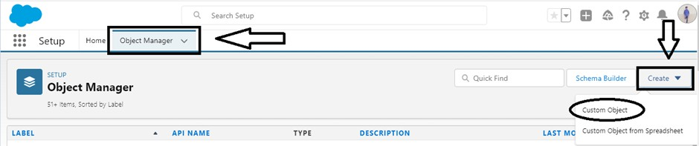

1. Enterthelabelname: JewelCustomer
2. Plurallabelname: JewelCustomers

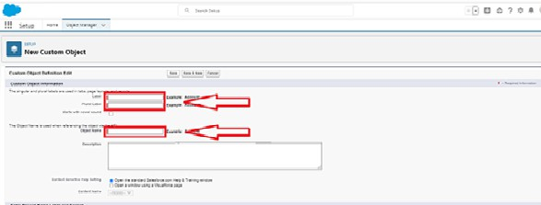

1. EnterRecordNameLabelandFormat
   * RecordName>>Customername
   * DataType>>Text

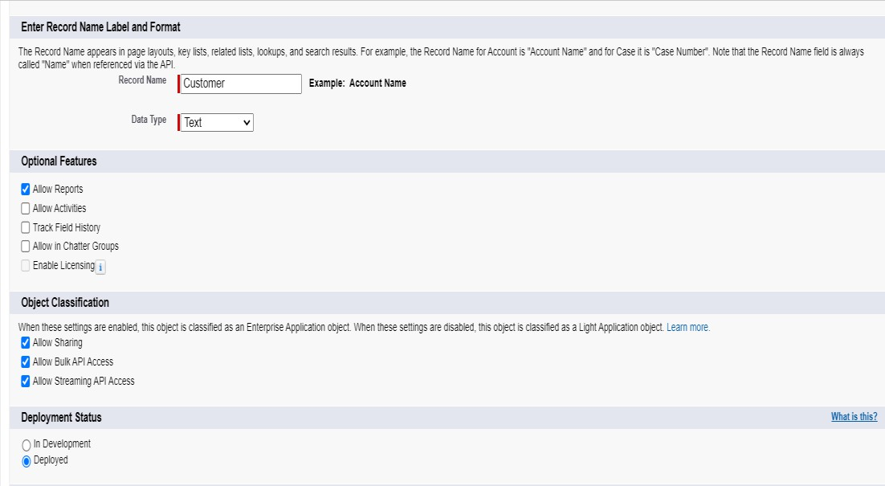

1. ClickonAllowreports.
2. AllowsearchandclickSave.

**Activity2:CreateItemObject**

ThepurposeofcreatingaItemobjectistomanagethe inventoryofgoldandsilveritems. To create an object:

1. Fromthesetuppage>>Click on Object Manager>>Click on Create>>Click on Custom Object.
2. Enterthelabelname>>Item
3. Plurallabelname>>Items
4. EnterRecordNameLabelandFormat
   * RecordName>>Item Id
   * DataType>>Auto Number
   * DisplayFormat>>Item-{00}
   * StartingNumber>>1
5. ClickonAllowreports.
6. Allowsearch>>Save.

## **Note:Create3moreobjectswithlabelnamesasCustomerOrder,Price,Billing**

**(**Use“AutoNumber”asadatatypeforCustomerOrder,Price,Billing).

# **Milestone3:Tabs**

**What is Tab:** Atabislikeauserinterfacethatisusedtobuildrecordsforobjectsandto view the records in the objects.

##### **TypesofTabs:**

1. **CustomTabs**

Custom object tabs are the user interface for custom applications that you build in salesforce.com.Theylookandbehavelikestandardsalesforce.comtabssuchasaccounts, contacts, and opportunities.

1. **WebTabs**

Web Tabs are custom tabs that display web content or applications embedded in the salesforce.comwindow.Webtabsmakeiteasierforyouruserstoquicklyaccesscontentand applications they frequently use without leaving the salesforce.com application.

1. **VisualforceTabs**

VisualforceTabsarecustomtabsthatdisplayaVisualforcepage.Visualforcetabslookand behave like standard salesforce.com tabs such as accounts, contacts, and opportunities.

1. **LightningComponentTabs**

LightningComponenttabsallowyoutoaddLightningcomponentstothenavigationmenuin Lightning Experience and the mobile app.

1. **LightningPageTabs**

LightningPageTabsletyouaddLightningPagestothemobileappnavigationmenu.

LightningPagetabsdon'tworklikeothercustomtabs. Oncecreated,theydon'tshowuponthe All Tabs page when you click the Plus icon that appears to the right of your current tabs.

LightningPagetabsalsodon'tshowupintheAvailableTabslist when youcustomizethetabs for your apps.

**UseCase:**

CreatingObjectsandstoringJewelsdataistheveryfirst stepintherequirementstheywant. Nowto access the stored data by an Owner(Gold Smith) in the organisation Admin needs to create Tabs.

By designing a dedicated Tab, businesses can improve user experience, simplify navigation, and providequickaccesstocriticalinformation,enhancingproductivityandensuringefficientutilisation of Salesforce's capabilities.

Activity1:CreatingaCustomTab

**Tocreatea Tab:(Customer)**

1. Gotosetuppage>>typeTabsinQuickFindbar>>clickontabs>>New(undercustom object tab)

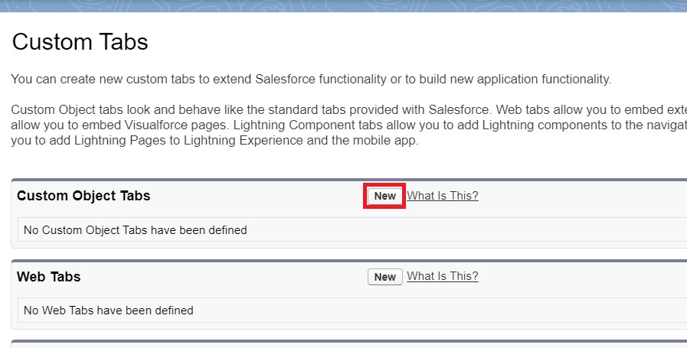

1. SelectObject(JewelCustomer)>>Selectanytabstyle>>Next(Addtoprofilespage)keepit as default >> Next (Add to Custom App) keep it as default >> Save.

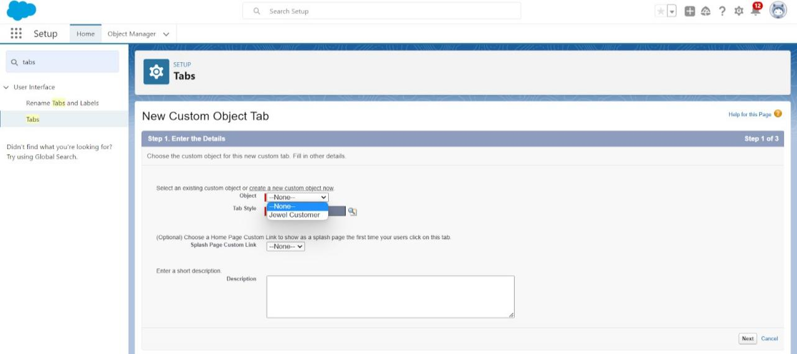

**Activity2:TocreateaTab:(Item)**

1. Gotosetuppage>>typeTabsinQuickFindbar>>clickontabs>>New(undercustom object tab)
2. SelectObject(Item)>>Select thetabstyle>>Next (Addtoprofilespage)keepit as default

>> Next (AddtoCustomApp)keepit asdefault >>Save.

Note:NowcreatetabsforCustomerOrder,Price,Billingobjects.

# **Milestoe4:TheLightningApp**

An app is a collection of items that work together to serve a particular function. In Lightning Experience,Lightningappsgivesusersaccesstosetsofobjects,tabs,andotheritemsallinone convenient bundle in the navigation bar.

Lightning apps let you brand your apps with a custom color and logo. You can even include a utility barandLightningpagetabsinyour Lightningapp.Membersofyourorgcanworkmoreefficientlyby easily switching between apps.

### **UseCase:**

Well done you have reached close to your requirement by creating the objects to store the organization’s data. Making a database for an organization is just not enough to reach out the requirements,thetaskishowtheusersattheorganizationcanaccess theobjectsyouhavecreated for them. As anAdminfor theorganizationit's your duty tomakesureevery user of theorganization is able to access the data modelling structure.

Activity1:CreateaLightningApp

Tocreatealightningapppage:

1. Gotosetuppage>> search“appmanager”inquickfind>>select “appmanager”>>
2. clickonNewlightningApp.

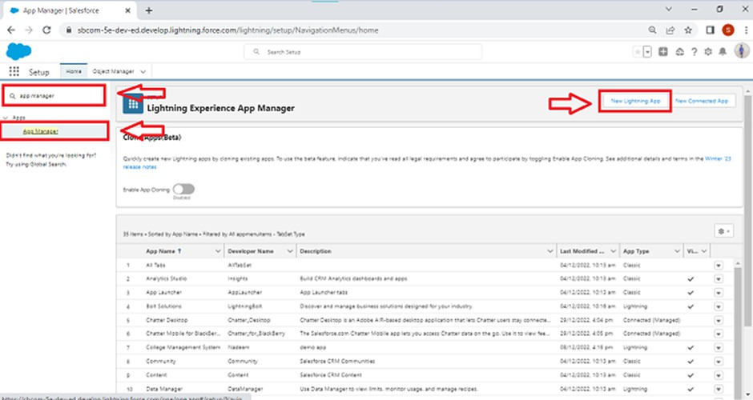

1. Filltheappnameinappdetailsandbrandingasfollow App Name :Jewellery Inventory System.

Developer Name :This will auto populated Description:Elevateyourlookwithelegance

Image:optional(ifyouwanttogiveanyimageyoucanotherwisenotmandatory)

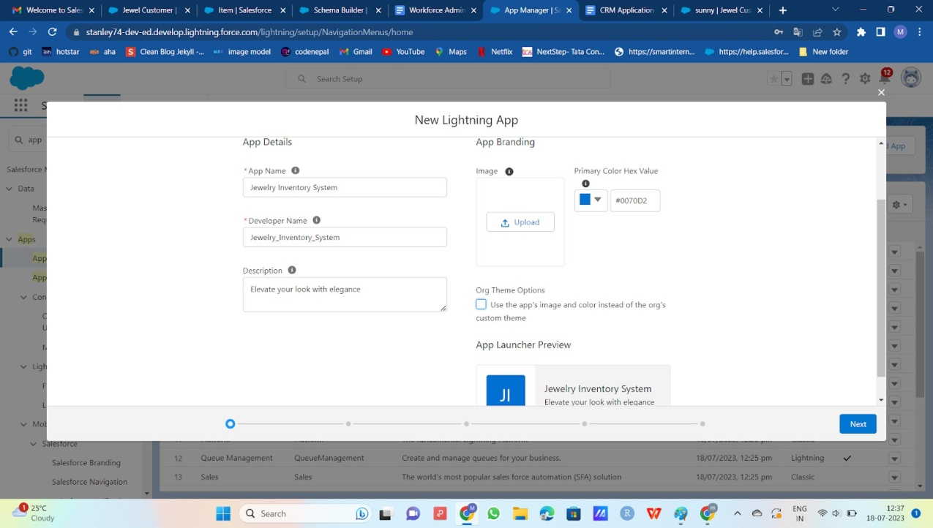Primarycolourhexvalue:keepthisdefault.

1. ThenclickNext>> (Appoptionpage)Set NavigationStyleasConsoleNavigation>>Next.

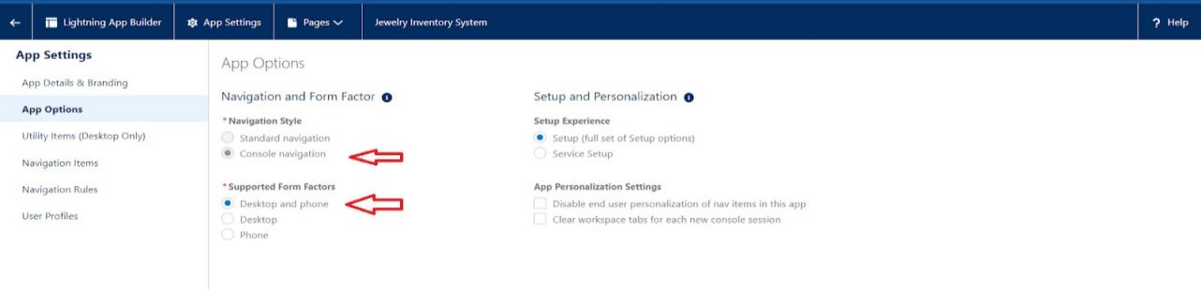

1. (UtilityItems)keepit asdefault >>Next.
2. 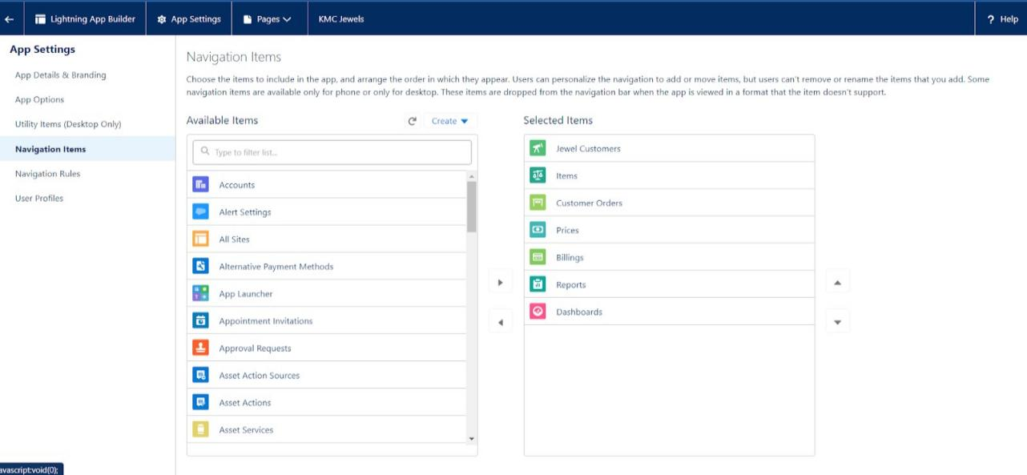ToAddNavigationItems:Search for the

(JewelCustomer,Item,CustomerOrder,Price,Billing,Reports, Dashboard) from the search barand move it using the arrow button ? Next? Next.

1. ToAddUserProfiles:

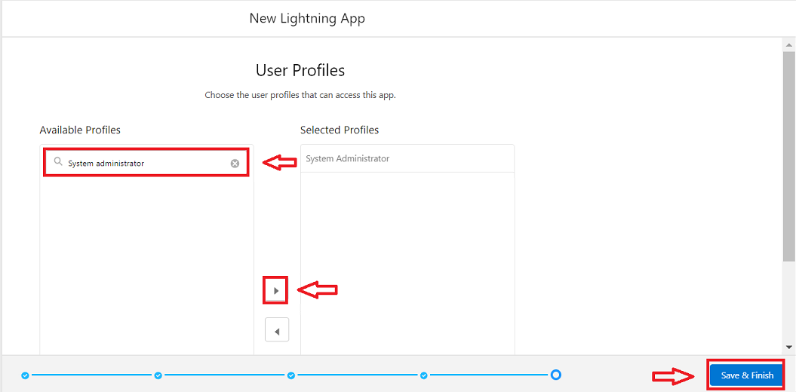

Searchprofiles(Systemadministrator)inthesearchbar>> clickonthearrowbutton>> save&finish.

# **Milestone5:Fields**

When we talk about Salesforce, Fields represent the data stored in the columns of a relational database.Itcanholdanyvaluableinformationthatyourequireforaspecificobject.Hence,the overall searching, deletion, and editing of the records become simpler and quicker.

TypesofFields:

1. StandardFields
2. CustomFields

StandardFields:

As thenamesuggests, theStandard Fieldsarethepredefined fields inSalesforcethat perform astandard task.Themainpointis thatyoucan’tsimplydeleteaStandard Fielduntilitisanon-requiredstandardfield.Otherwise,usershavetheoptiontodelete them atanypointfrom theapplicationfreely.Moreover,wehavesomefields thatyou willfind commoninevery Salesforceapplication. They are,

>>CreatedBy

>>Owner

>>LastModified

>>FieldMadeDuringobjectCreation

CustomFields:

Ontheothersideofthecoin,Custom Fields arehighly flexible,and users canchange themaccordingtorequirements.Moreover,eachorganiserorcompanycanusethemif necessary.Itmeans youneed notalways includethem intherecords,unlikeStandard fields. Hence, thefinaldecisiondepends onthe user, and hecanadd/removeCustom Fields of any given form.

##### **UseCase:**

Now it’s time for you to think out of the box for your organisation. You have successfully created the databaseobjectsfortheorganisationbut nowalleyesturnonyouasyouhavetodefinewhat sort of information the objects store which you have created. As a life saver of your organisation you come up with the idea of creating fields to store different types of data.

Activity1:CreatingLookupRelationship

A Lookup relationship is a type of relationship in Salesforce that connects two objects togetherbasedonafieldknownastheLookupfield. It establishesarelationshipbetweenachildobject anda parent object, allowing the child object to reference the parent object.

#### **ToCreatearelationshipbetweenJewelCustomer&CustomerOrderObjects.**

1. Gotothesetuppage>>clickonobjectmanager>>typeobjectname(CustomerOrder)in the quick find bar >> click on the object.
2. Clickonfields&relationship>> clickonNew.
3. Select“Lookuprelationship”asdatatypeandclick Next.
4. Selecttherelatedobject “JewelCustomer”.
5. GiveFieldLabel as“Customer”andclickNext.
6. Next>>Next>>Save.

Activity2:CreatingaMaster-DetailRelationship

Master-detailrelationshipisatypeofrelationshipbetweentwoobjectswherethemasterobject controls certain behaviours and settings of the detail object. Here are a few use cases that demonstrate the use of master-detail relationships

CreatingMaster-DetailRelationshipbetweenItem&CustomerOrderObject. To Create a Master-Detail relationship :

1. Gotothesetuppage>> clickonobject manager>>typeobject name(CustomerOrder)inthe quick find bar >> click on the object.
2. Clickonfields&relationships>> clickon New.
3. Select“Master-Detailrelationship”asdatatypeandclick Next.
4. Select therelatedobject “Item”.
5. GiveFieldLabelas“Item”andclickNext.
6. Next>>Next>>Save.

**Activity3:CreatingTextFieldinJewelCustomerObject**

Tocreatefieldsin anobject:

* 1. Gotosetup>>clickonObjectManager>>typeobjectname(JewelCustomer)in quick find bar >> click on the object.

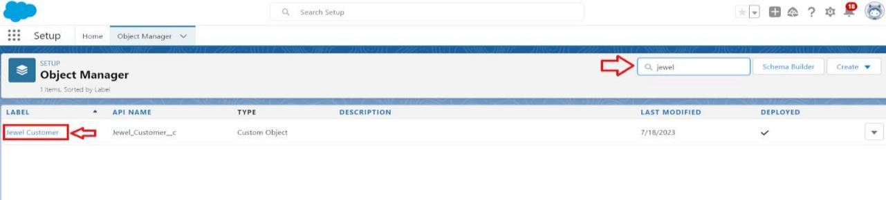

* 1. Nowclickon“Fields&Relationships”>>New

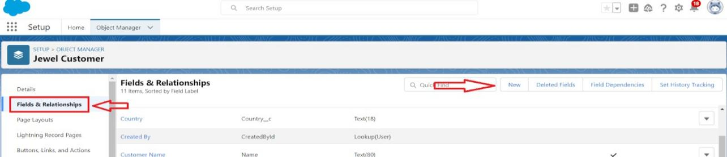

* 1. SelectDatatypeas “Text”.

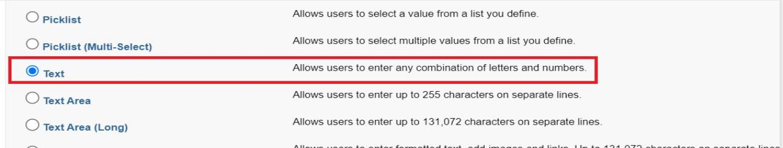

4..ClickonNext

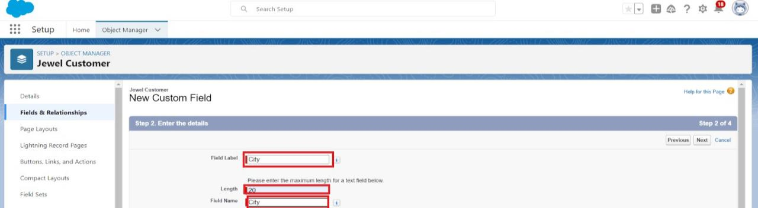

* 1. Filltheaboveasfollowing:
     + FieldLabel:City
     + Length:20
     + FieldName:getsautogenerated
     + ClickonNext>>Next>>Saveandnew.

#### **Activity4:CreatingthePhonefieldinobjectJewelCustomer**

Tocreatefieldsin anobject:

1. Gotosetup>>clickonObjectManager>>typeobjectname(JewelCustomer)in quickfind bar>>clickontheobject.
2. Nowclickon“Fields&Relationships”>>New
3. SelectDatatypeas“Phone”andclickNext.
4. GiventheFieldLabelas“Phone”.

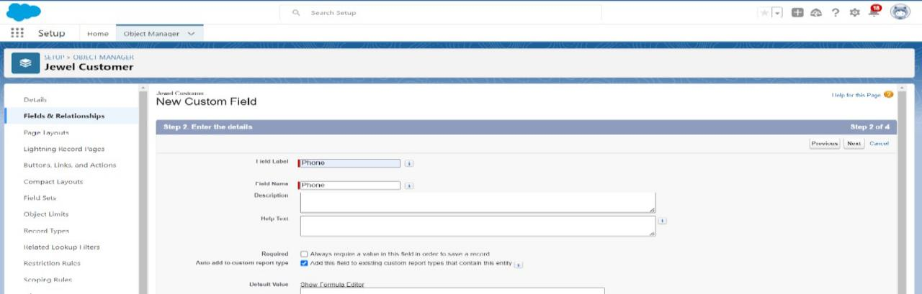

1. FieldNamewillbeautopopulated,andclickonNext>>Next >>Save&new.

#### **Activity5:CreatingtheEmailfieldinobjectJewelCustomer**

Tocreatefieldsinanobject:

1. Gotosetup>>clickonObjectManager>>typeobjectname(JewelCustomer)in quickfind bar>>clickontheobject.
2. Nowclickon“Fields&Relationships”>>New
3. SelectDatatypeas“Email”andclickNext.
4. GiventheFieldLabelas“Email”.
5. FieldNamewillbeautopopulated,andclickonNext>> Next>>Save.

**Activity6:CreatingthenumberfieldinItemobject**

Tocreatefieldsin anobject:

1. Gotosetup>> clickonObjectManager>> typeobject name(Item)inquickfindbar?clickon the object.
2. Nowclickon“Fields&Relationships”>>New
3. SelectDatatypeas“Number”andclickNext.
4. GiventheFieldLabelas“Purity”andlengthas“2”.

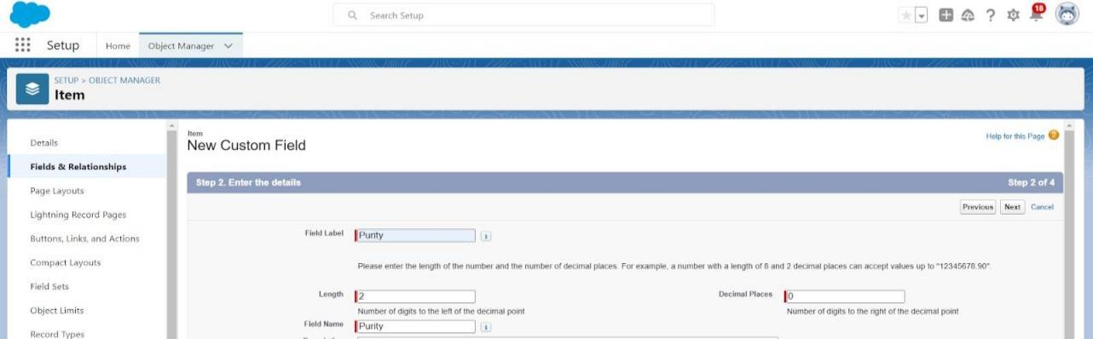

1. FieldNamewillbeautopopulated,andclickonNext>> Next>>Save.

**Activity7:CreatingPicklistFieldinItemObject**

**Tocreatefieldsin anobject:**

1. Gotosetup>>clickonObjectManager>>typeobjectname(Item)inquickfindbar>>click on the object.
2. Nowclickon“Fields& Relationships”>>New.
3. SelectDatatypeas“Picklist”andclickNext.
4. EnterFieldLabelas“ItemType”.
5. Invaluesselect“Entervalues(Gold,Silver), witheachvalueseparatedbyanewline"and

entervaluesasshownbelow.

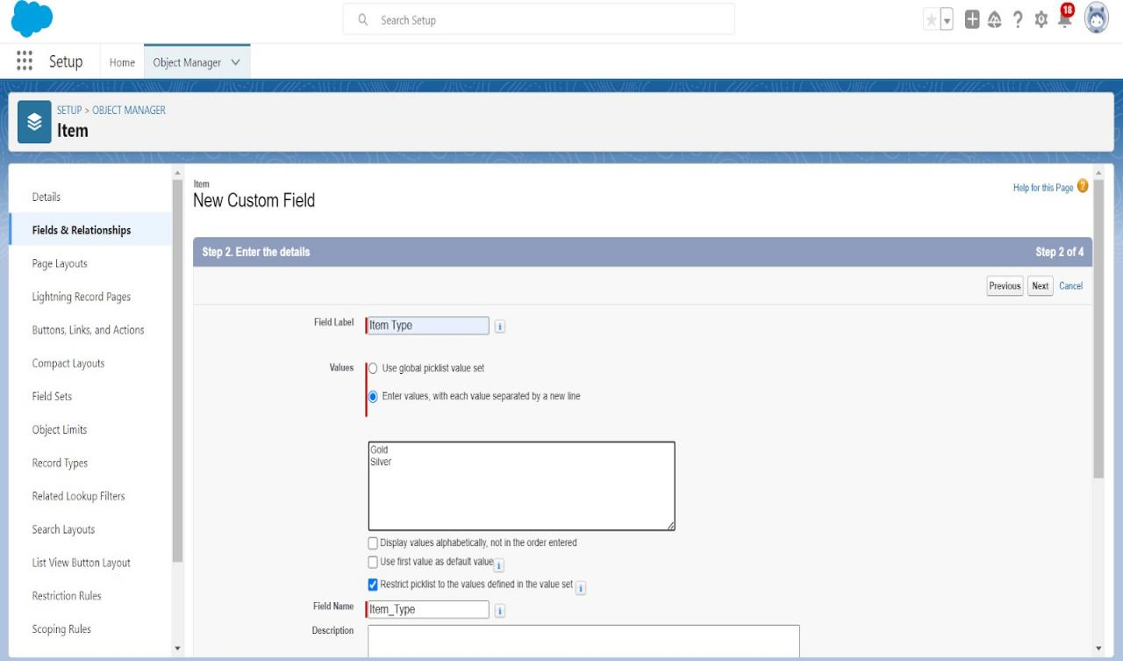

1. ClickNext?Next?Next?Save.

**Activity8:CreatingCurrencyFieldinPriceObject**

Tocreatefieldsin anobject:

1. Gotosetup>> clickonObjectManager>> typeobject name(Price)inquickfindbar>> clickonthe object.
2. Nowclickon“Fields&Relationships”>>New.
3. 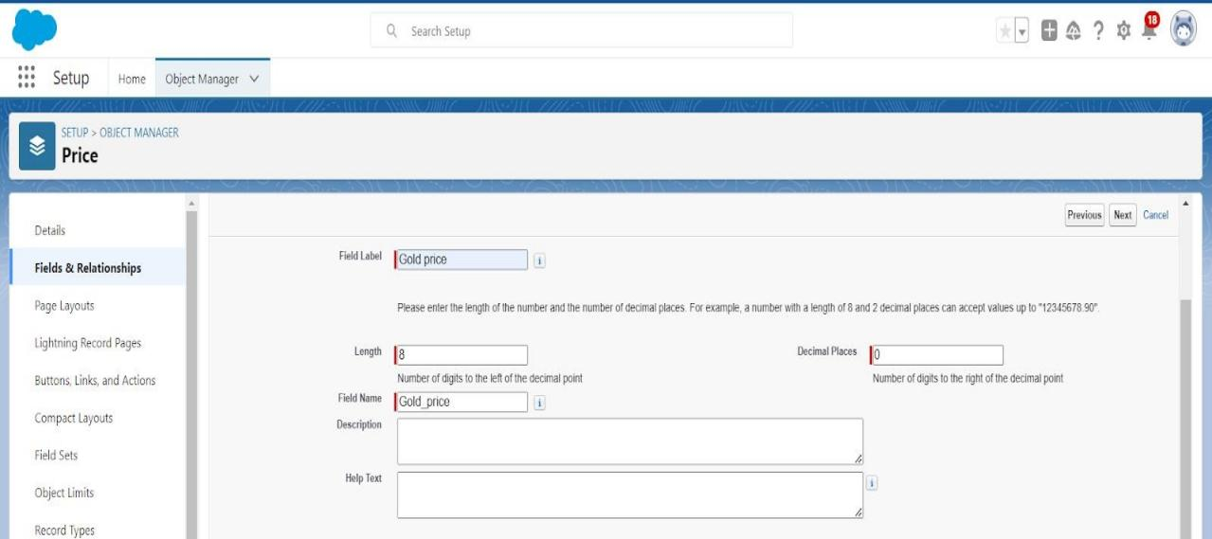SelectDatatypeas“Currency”andclickNext.
4. EnterFieldLabelas“GoldPrice”andlengthas“8”anddecimal0.Fieldnamewillbeautogenerated.
5. ClickNext >> Next>> Next >>Save.

#### **Activity9:CreatingFormulaField(CrossObject)inItemObject**

Tocreatefieldsin anobject:

(Note:CreateaLookupRelationshipinItemObject toPriceObject withFieldName:Prices)

1. Gotosetup>> clickonObjectManager>>typeobjectname(Item)inquickfindbar?clickontheobject.
2. Nowclickon“Fields&Relationships”>>New.
3. SelectDatatypeas“Formula”andclickNext.
4. GiveFieldLabelandFieldNameas“GoldPrice”andselectformulareturntypeas“Currency”

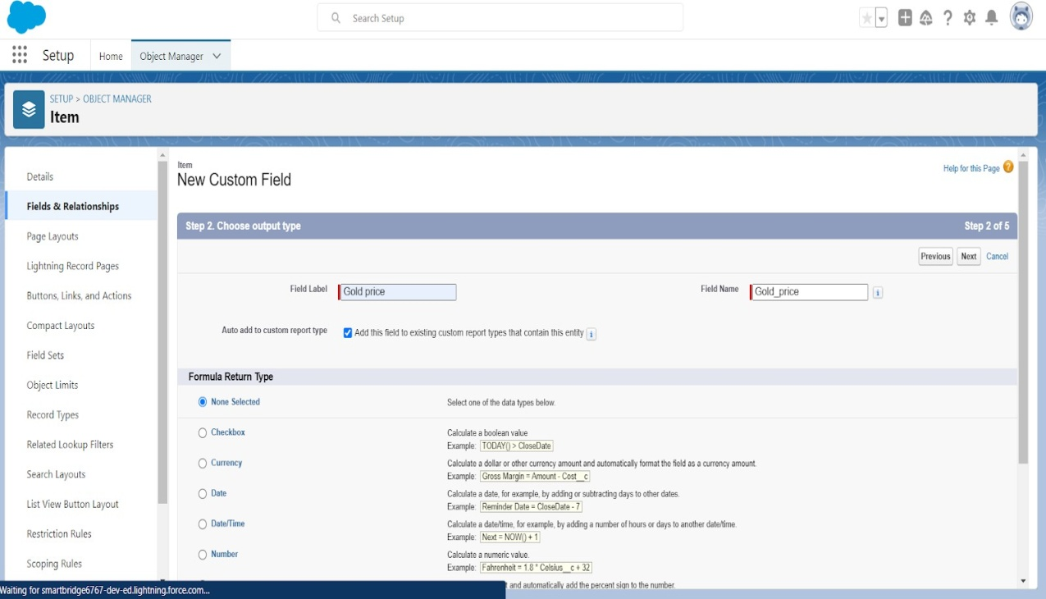andclicknext.

5.UnderAdvancedFormulawritedowntheformula:Pricesr.Gold_pricec/10.

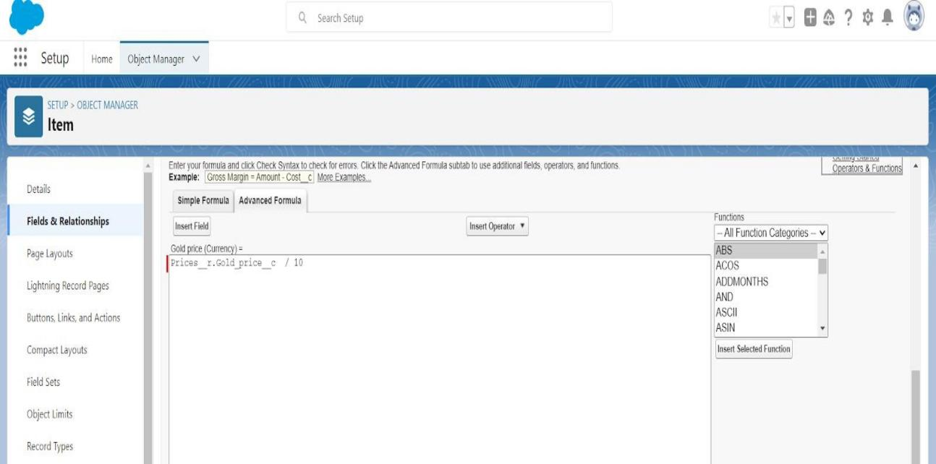

6.click“CheckSyntax”andNext >> Next>> Save&New.

**Activity10:CreatingRemainingFieldsinObjects**

|  |  |
| --- | --- |
|  |  |
|  |  |
|  |  |

Nowcreatetheremainingfieldsusingthedatatypesmentioned.

|  |  |
| --- | --- |
|  |  |
|  |  |
|  |  |
|  |  |
|  |  |

|  |  |  |
| --- | --- | --- |
| s.no | Objectname | Fields |
| 1 | JewelCustomer | FieldName Datatype  State Text(20)  Street Text(20)  Country Text(18)  Zip/Postalcode Text(6) |

|  |  |  |
| --- | --- | --- |
| 2 | Price | SilverPrice Currency (Length=8,Decimal=5) |

|  |  |  |
| --- | --- | --- |
| 3 | Item | FieldLabel:Customer Name LookupRelationshipwithJewel  CustomerObject  Ornament Text(20)  Weight Number  (Length=8,Decimal=5) |

|  |  |  |  |
| --- | --- | --- | --- |
|  |  |  |  |
| Stone Weight |  | Number (Length=5,Decimal=5) |  |
| Percentage |  | Number (Length=2,Decimal=0) |  |
| Stone/OtherPrice |  | Currency (Length=8,Decimal=2) |  |
| ExpectedDaysOfReturn |  | Picklist  1-3Days  4-5Days  6-7Days  8-10 Days |  |
|  |  |  |  |
| Priority |  | Picklist  Low Medium High Critical |  |
|  |  |  |  |
| SilverPrice |  | Formula  (ReturnType:Number) (Decimal=3)  (Pricesr.Silver_pricec/ 1000) |  |
|  |  |  |  |
| PurityGoldPrice |  | Formula  (ReturnType:Currency) (Decimal=2)  ((Pricesr.Gold_pricec* Purity c ) / 24) / 10 |  |
|  |  |  |  |
| TotalWeight |  | Formula  (ReturnType:Number) (Decimal=3) |  |

|  |  |
| --- | --- |
|  | (Weightc- Stone_weightc) |
| Amount | Formula  (ReturnType:Currency) (Decimal=3)  IF(ISPICKVAL( Item_Type c ,"Gold"), Total_weightc  *Purity_Gold_pricec,Total_weightc* Silver_pricec ) |
| KDM | Formula  (ReturnType:Currency) (Decimal=0)  (Amountc * Percentagec)/100 |
| MakingCharges | Formula  (ReturnType:Currency) (Decimal=0)  IF(ISPICKVAL( Item_Type c ,"Gold"),Weightc*  300 ,Weightc*10 ) |

|  |  |  |
| --- | --- | --- |
| 4 | CustomerOrder | OrderStatus Picklist  Started  NotStarted On Hold Completed  NotCompleted |

5 Nowcreatetheremainingfieldsusingthedatatypes mentioned.

|  |  |
| --- | --- |
|  |  |
|  |  |
|  |  |
|  |  |
|  |  |

|  |  |  |
| --- | --- | --- |
| F  i e l d L  a b e l: Ite m |  | Lookup Relationship  withItem  Object |
| O  rn a m e nt |  | Formula (ReturnType:Text)  Itemr.Ornament c |
| S  t o n e w eig h t |  | Formula (Return  Type:Number)  (Decimal=2)  Itemr.Stone_weightc |
| W  e i g h t |  | Formula Return  Type:Number  (Decimal=2)  Itemr.Total_weight  c |
|  |  |  |

|  |  |  |  |
| --- | --- | --- | --- |
| s  .  n o | O  bje ctn a m e | Fields | |
| 1 | J  e w el C  u sto m er | FieldName | Datatype |
|  | State | Text(20) |
|  | Street | Text(20) |
|  | Country | Text(18) |
|  | Zip/Postalcode | Text(6) |

|  |  |  |  |  |
| --- | --- | --- | --- | --- |
| 2 | P  ric e |  | Silver Currency  Price (Length=8,Decimal  =5) |  |
|  |  |  |  |  |

|  |  |  |
| --- | --- | --- |
| 3 | Item |  |

|  |  |
| --- | --- |
|  |  |
| F  i e l d L  a b e l  : C  u sto m er N  a m e | Lookup Relationshipwith Jewel Customer Object |
| O  rn a m e nt | Text(20) |
| W  e i g h t | Number (Length=8,Decimal=5) |
| S  tone W  e i | Number (Length=5,Decimal=5) |

|  |  |  |
| --- | --- | --- |
|  |  |  |

|  |  |  |
| --- | --- | --- |
|  |  |  |
| A  m o u nt |  | Formula  (Return Type:Currency) (Decimal=2)  Itemr.Amountc |
|  |  |  |
| G  o l d  / S  il v e r P  ric e |  | Formula  (Return Type:Currency) (Decimal=2)  IF(ISPICKVAL(Item  r.Item_Typec," Gold"),  Itemr.Gold_price_  _c,  Itemr.Silver_price  c) |
| K D M C  h a r g e |  | Formula  (Return Type:Currency) (Decimal=0)  Itemr.KDMc |
| M  a kin g C  h a r g e s |  | Formula  (Return Type:Currency) (Decimal=2)  Itemr.Making_Chargesc |
| S  t o n |  | Formula  (Return Type:Currency) (Decimal=2) |

|  |  |
| --- | --- |
| g h t |  |
| P  e r c e n t a g e | Number (Length=2,Decimal=0) |
| S  t o n e  / O  t h e r P  ri c e | Currency (Length=8,Decimal=2) |
| E  x p e cte d D  a y s O  f R  e t | Picklist  1-3Days  4-5Days  6-7Days  8-10 Days |

|  |  |  |
| --- | --- | --- |
|  |  |  |
|  |  |  |
| e  s  / o t h e r p ric e |  | Itemr.Stone_other  _pricec |
| T  o t a l A  m o u nt |  | Formula  (Return Type:Currency) (Decimal=0)  Amountc+ KDM_Chargec+ Stones_other_price_  _c+ Making_Chargesc |

|  |  |
| --- | --- |
| u r n |  |
| P  ri o rit y | Picklist  Low Medium High Critical |
| S  ilv e r P  ri c e | Formula (Return  Type:Number) (Decimal=3)  (Pricesr.Silver  _pricec/ 1000) |
| P  u rit y  G  old P  ri c e | Formula (Return  Type:Currency)  (Decimal=2)  ((Pricesr.Gold  _pricec * Purityc)/24)  /10 |
| T  otal W  e i | Formula  (Return Type:Number) (Decimal=3) |

|  |  |  |  |
| --- | --- | --- | --- |
|  |  |  |  |
|  |  |  |  |
| g  h t |  | (Weightc- Stone_weight c) |  |
|  |  |  |  |
| A  m o u nt |  | Formula (Return Type:Currency) (Decimal=3)  IF(ISPICKVAL(I  tem_Typec ," Gold"), Total_weightc  * Purity_Gold_pricec,Total_weightc  *  Silver_pricec) |  |
|  |  |  |  |
| K D M |  | Formula (Return Type:Currency) (Decimal=0)  (Amountc * Percentagec  )/100 |  |
|  |  |  |  |
| M  a kin g C  h a r g e s |  | Formula (Return Type:Currency) (Decimal=0)  IF(ISPICKVAL(I  tem_Typec," Gold"),  Weightc* 300 ,  Weightc* 10 ) |  |
|  |  |  |  |

|  |  |  |
| --- | --- | --- |
|  |  |  |
|  |  |  |
|  |  |  |

|  |  |  |
| --- | --- | --- |
| 4 | Custo merOrder | Picklist  O  r   1. Started 2. NotStarted   r On Hold  S Completed  t NotCompleted a  t u s |

|  |  |  |
| --- | --- | --- |
| 5 | Billing | F Lookup  i Relationship  e withItem  l Object d  L  a b e l:  Ite m  Formula  O (ReturnType:Text) r  n Itemr.Ornament a c  m  e n t  Formula  S (Return  t Type:Number)  o (Decimal=2) n  e |

|  |  |  |
| --- | --- | --- |
|  |  |  |
|  |  |  |
| w  e i g h t |  | Itemr.Stone_weigh tc |
| W  e i g h t |  | Formula Return  Type:Number  (Decimal=2)  Itemr.Total_weight  c |
|  |  |  |
| A  m o u nt |  | Formula  (Return Type:Currency) (Decimal=2)  Itemr.Amountc |
|  |  |  |
| G  o l d  / S  il v e r P  ric e |  | Formula  (Return Type:Currency) (Decimal=2)  IF(ISPICKVAL(Item  r.Item_Typec," Gold"),  Itemr.Gold_price_  _c,  Itemr.Silver_price_  _c) |
| K D M C  h a r g e |  | Formula  (Return Type:Currency) (Decimal=0)  Itemr.KDMc |

|  |  |  |
| --- | --- | --- |
|  |  |  |

Billing

|  |  |  |
| --- | --- | --- |
|  |  |  |
| M  a kin g C  h a r g e s |  | Formula  (Return Type:Currency) (Decimal=2)  Itemr.Making_Chargesc |
| S  t o n e s  / o t h e r p ric e |  | Formula  (Return Type:Currency) (Decimal=2)  Itemr.Stone_other  _pricec |
| T  o t a l A  m o u nt |  | Formula  (Return Type:Currency) (Decimal=0)  Amountc+ KDM_Chargec+ Stones_other_price_  _c+ Making_Chargesc |

**Activity11:SchemaBuilder**

SchemaBuilderis apowerfultoolwithinSalesforcethatallowsyoutovisualise,explore,anddesign the relationships between objects in your Salesforce organisation. It provides a graphical representation of the data model, making it easier to understand the structure and connections between different objects.

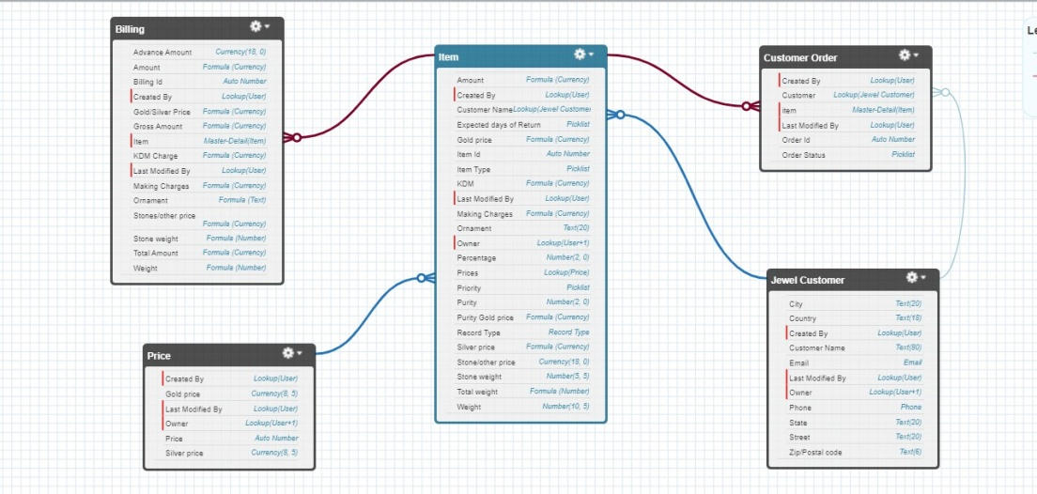

**Activity12:CreatingtheFieldDependencies**

Usecase:

FieldDependenciesareusedtocreaterelationshipsbetweenfieldswithinanobject. Theyallowyou to control the visibility and availability of fields based on the values selected in other fields.

1. Gotosetup>>clickonObjectManager>>typeobjectname(Item)inquickfindbar>>click on the object.
2. ClickonFields&RelationshipsandclickonthePriorityfield.
3. 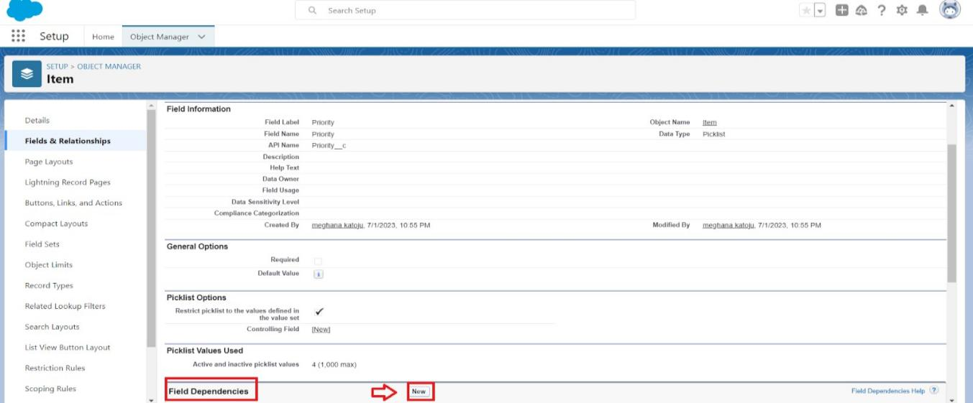SearchforFieldDependenciesandclickonNew.
4. SelectControllingFieldas“Priority”andDependingfieldas“ExpectedDaysof Return” >> Continue.

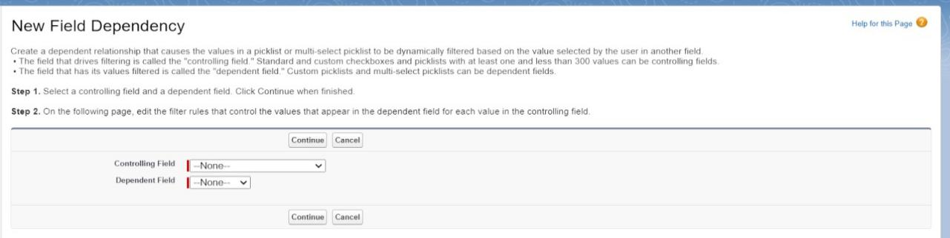

1. Selectthe“ExpectedDaysofReturn”valuesofrelatedPriorityvaluesandClickon

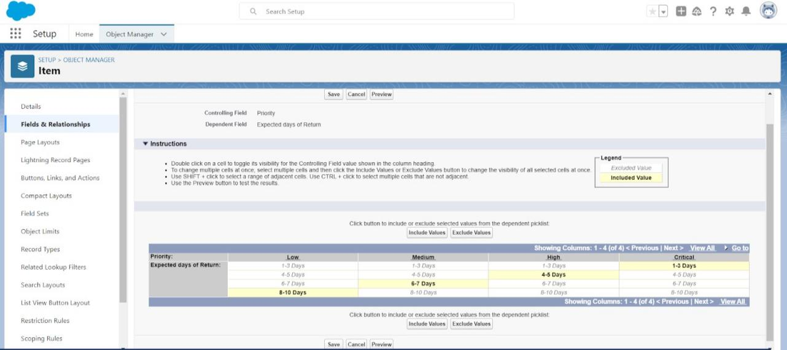IncludeValues>>Save.

**Activity13:Creatingthevalidationrule**

CreatingthevalidationruleforPostalCodefieldinJewelCustomerobject

Note:checkwhetherthefieldsmentionedintheformulafieldarecreatedornot,ifnot gotoactivity 10 and createthosefields mentioned inJewelCustomer object.

1. Gotosetup>>clickonObjectManager>>typeobjectname(JewelCustomer)in quickfind bar>> clickontheobject.
2. Clickonthevalidationrule>> clickNew.

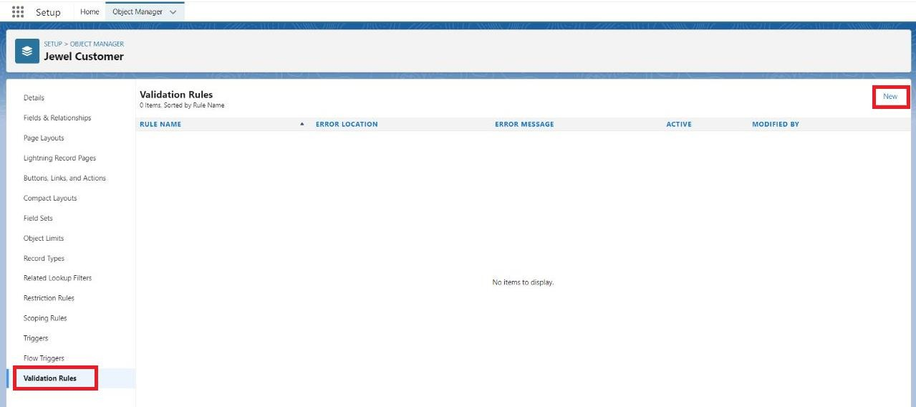

1. EntertheRule nameas“PostalCode“.
2. InserttheErrorConditionFormulaas:- AND(

OR(

LEN( Zip_Postal_codec )<>6, NOT(REGEX(Zip_Postal_codec, "^[0-9]{6}$"))), NOT(ISBLANK(Zip_Postal_codec))

)

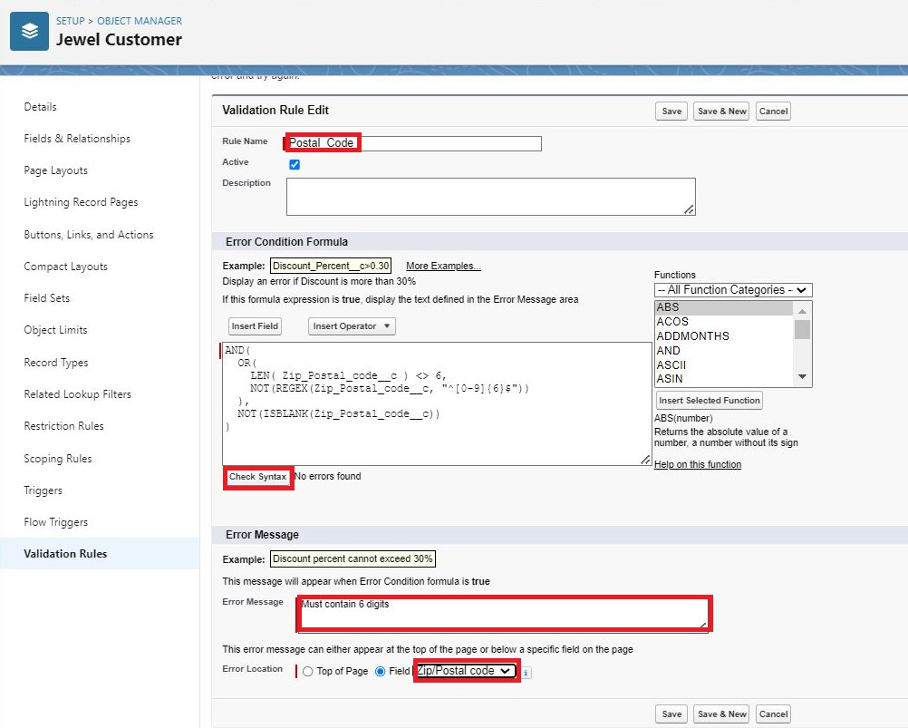)

1. EntertheErrorMessageas“Mustcontain6digits”,selecttheErrorlocationasFieldand select the field as “Zip/Postal code”, and click Save.

**NOTE:**

**CreateOnemoreValidationruleforJewelCustomer object.**

1. EnterRulenameas“ValidationRuleForJewelCustomerObject“.
2. InserttheErrorConditionFormulaas:- OR(ISBLANK(Cityc),

ISBLANK(Countryc),ISBLANK(Phonec),ISBLANK(Statec),ISBLANK( Streetc ) )

1. EntertheErrorMessageas“PleasefillRequiredfields”, selecttheErrorlocationasTopof

PageandclickSave.

CreateValidationruleforItemobject.

1. EnterRulenameas“ValidationRuleForItem“.
2. InserttheErrorConditionFormulaas:- OR(ISBLANK(Amountc),

ISBLANK(Customer_Namec),ISBLANK(Gold_pricec),ISBLANK(KDMc),ISBLANK(Ornamentc),ISBLANK(Percentagec),ISBLANK(Making_Chargesc), ISBLANK(Pricesc),ISBLANK(Stone_weightc),ISBLANK(Silver_pricec),ISBLANK(Stone_other_pricec),ISBLANK(Stone_weightc),ISBLANK(Weightc))

1. EntertheErrorMessageas“PleasefillRequiredfields”, selecttheErrorlocationasTopof

PageandclickSave.

# **Milestone6:Profiles**

Aprofileisagroup/collectionofsettingsandpermissionsthatdefinewhatausercando insalesforce.Profilecontrols“Objectpermissions,Fieldpermissions,Userpermissions, Tabsettings,Appsettings,Apexclassaccess,Visualforcepageaccess,Pagelayouts, RecordTypes,Loginhours&LoginIPranges.Youcandefineprofilesbytheuser'sjob function.ForexampleSystemAdministrator,Developer,SalesRepresentative.

Typesofprofilesinsalesforce

1. Standardprofiles:

Bydefaultsalesforceprovidesbelowstandardprofiles.

* + ContractManager
  + ReadOnly
  + MarketingUser
  + SolutionsManager
  + StandardUser
  + System Administrator.

Wecannotdeletedstandard ones

Eachofthesestandardonesincludesa defaultsetofpermissionsforallofthestandardobjects available on the platform.

1. CustomProfiles:

Customonesdefinedbyus.

Theycanbedeletedif therearenousersassignedwiththat particularone.

**UseCase:**

Great work Admin, you have done so good till now. The GoldSmith wants to differentiate the users based on their functionalities, position and based on this those users need to have the minimum access tothedatabaseobject intheorganisation. Now it's timetouseyour Adminskills tofocus on theusers, theirfunctionalityandpositionintheorganisationinordertoachievetheGoldsmithSmith requirements.

**Activity1:GoldSmithProfile**

Tocreateanewprofile:

1. Gotosetup>>typeprofilesinquickfindbox>>clickonprofiles?clonethedesiredprofile (System Administrator) >> enter profile name (Gold Smith) >> Save.

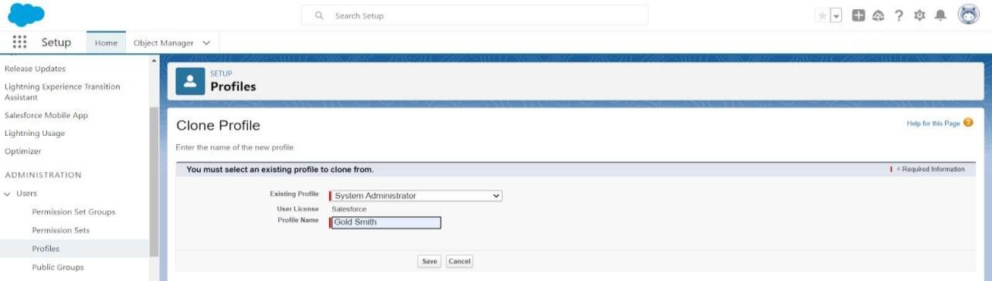

1. Whilestillontheprofilepage, thenclickEdit.
2. 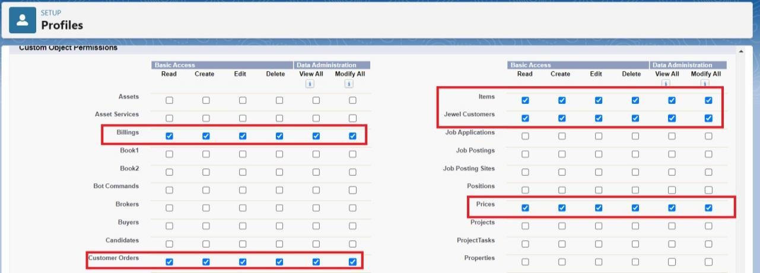ScrolldowntoCustomObjectPermissionsandGiveaccesspermissionsforJewel Customer,Item,CustomerOrder,Prices,Billings .
3. ScrolldownandClickon Save.

# **Milestone7:Roles**

A role in Salesforce defines a user's visibility access at the record level. Roles may be used to specifythetypesofaccessthatpeopleinyourSalesforceorganisationcanhavetodata.Simplyput, it describes what a user could see within the Salesforce organisation.

### **UseCase:**

You have successfully fulfilled the 1st requirement i.e., differentiating the users based on the functionality.Nowcomesthe2ndtaskofdifferentiating theusersbasedontheirposition,usingyour excellent admin skills and expanding the custom roles for the organisation and assigning it to the users.

Activity1:CreatingGoldSmithRole

1. Fromsetup,Gotoquickfind>> SearchforRoles>> clickonset uproles.

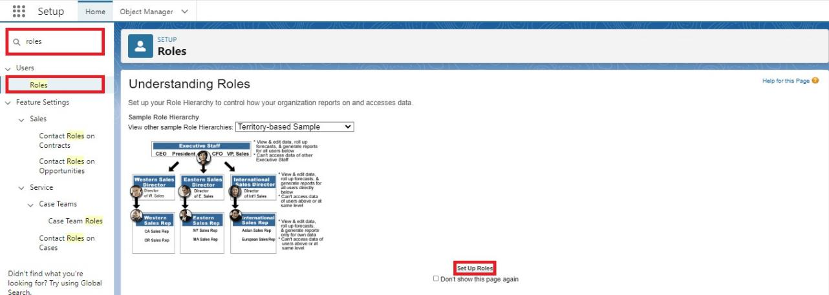

1. ClickonExpandAllandclickonaddroleunderwhomthisroleworks.

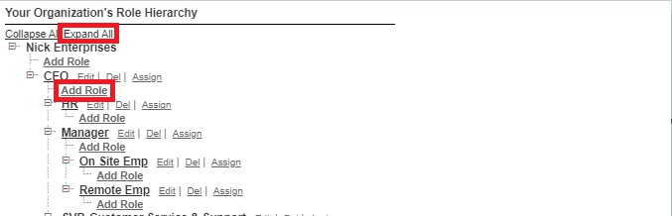

1. GiveLabelas“GoldSmith”andRolenamegetsauto populated.Checktowhomthisrole (Gold Smith) reports. Then click on Save.

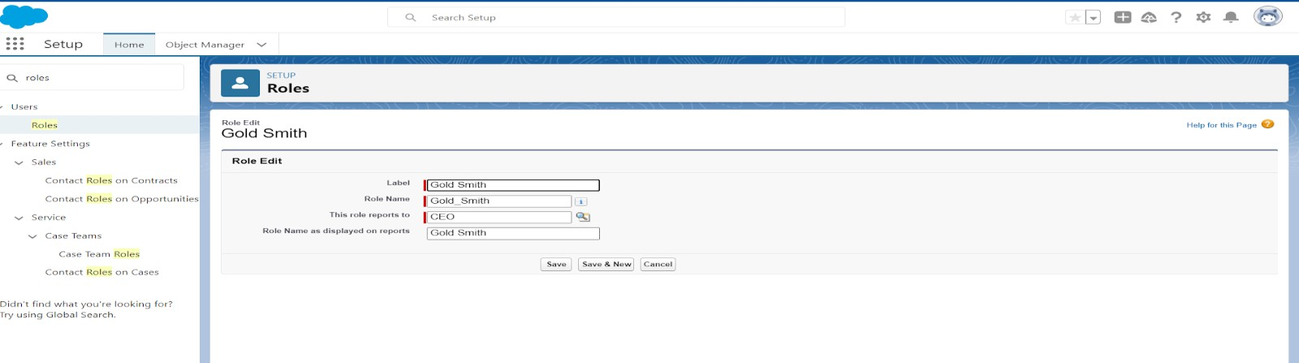

**Activity2:CreateonemoreroleasWorkerwhichreportstoGoldSmith.**

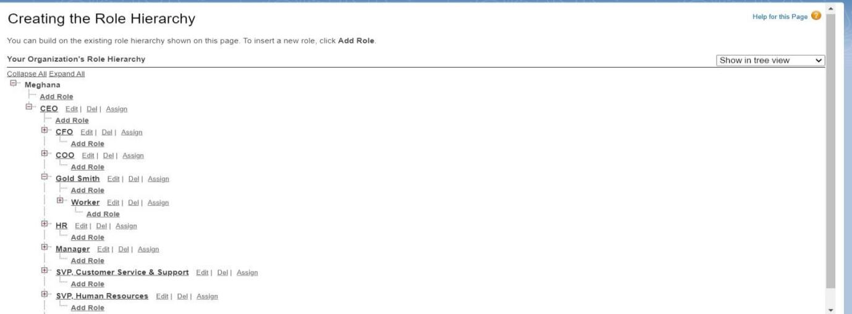

# **Milestone8:Users**

AuserisanyonewhologsintoSalesforce.Users areemployeesatyour company,such assalesreps,managers,andITspecialists,whoneedaccesstothecompany'srecords. EveryuserinSalesforcehasauseraccount.Theuseraccountidentifiestheuser,andthe user account settings determine what features and records the user can access.

EveryuserinSalesforcehasauseraccount.Theuseraccountidentifiestheuser,andthe user account settings determine what features and records the user can access. Each user account contains at least the following:

* + Username
  + EmailAddress
  + User'sFirstName(optional)
  + User'sLastName
  + Alias
  + Nickname
  + Licence
  + Profile
  + Role(optional)

**Activity1:CreateUser**

1. Gotosetup>>typeusersinquickfindbox>>select users>>clickNewuser.
2. Fillinthefields
3. FirstName :Niklaus
4. LastName :Mikaelson
5. Alias :GiveaAliasName
6. Emailid:GiveyourPersonalEmailid
7. Username :Usernameshouldbeinthisform:[text@text.text](mailto:text@text.text)
8. NickName :GiveaNickname
9. Role :GoldSmith
10. Userlicence :Salesforce
11. 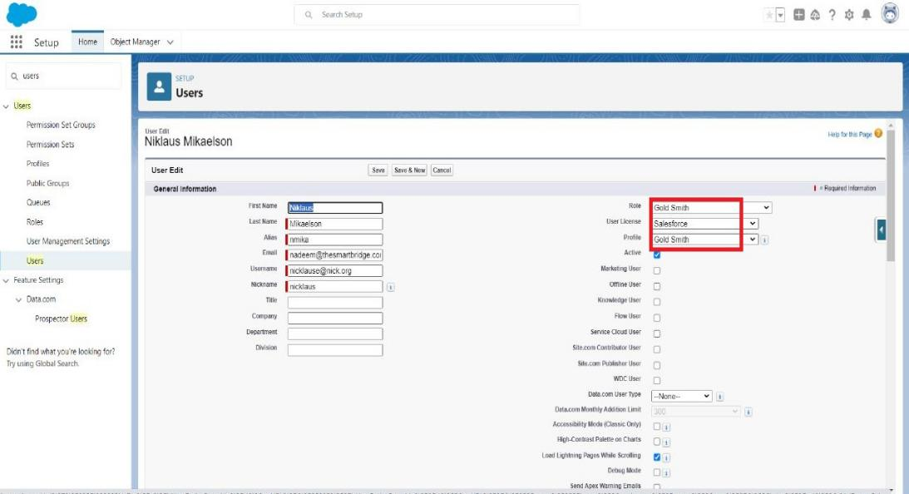Profiles:GoldSmith

10.Save.

**Activity2:CreateUser**

* 1. Gotosetup>>typeusersinquickfindbox>>select users>>clickNewuser.
  2. Fillinthefields
     + FirstName:Kol
     + LastName:Mikaelson
     + Alias:GiveaAliasName
     + Emailid:GiveyourPersonalEmailid
     + Username:Usernameshouldbeinthisform:[text@text.text](mailto:text@text.text)
     + NickName:GiveaNickname
     + Role:Worker
     + Userlicence:SalesforcePlatform
     + Profiles:Worker
  3. Save.

Note:Createtwomoreusersasmentionedinactivity2usingthesameprofile.

# **Milestone9:Pagelayouts**

PageLayoutinSalesforceallowsustocustomisethedesignandorganise detailandedit pages ofrecords inSalesforce. Pagelayouts canbeused tocontroltheappearanceof fields,related lists,and custom links onstandardand custom objects' detailand edit pages.

### **UseCase:**

Hurray!! youhavecompletedthedatamodelstructureforyourorganisationbut whilelookingat the detailedandedit pagesit seemstobesoclumsy, sodecidetoorganisethepageinapleasant way for the sake of good and pleasant appearance and assemble all different kinds of information in different sections in order.

**Activity1:ToCreateaGoldPagelayout**

1. GotoSetup>> ClickonObject Manager>> Searchfortheobject (Item)>>Fromdropdown click on Edit.
2. 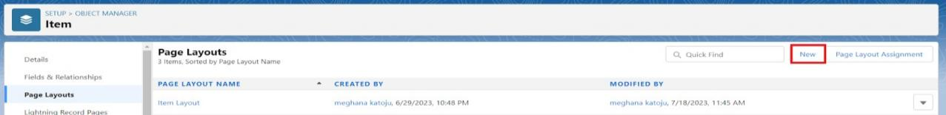ClickonPagelayout>>ClickonNew.
3. 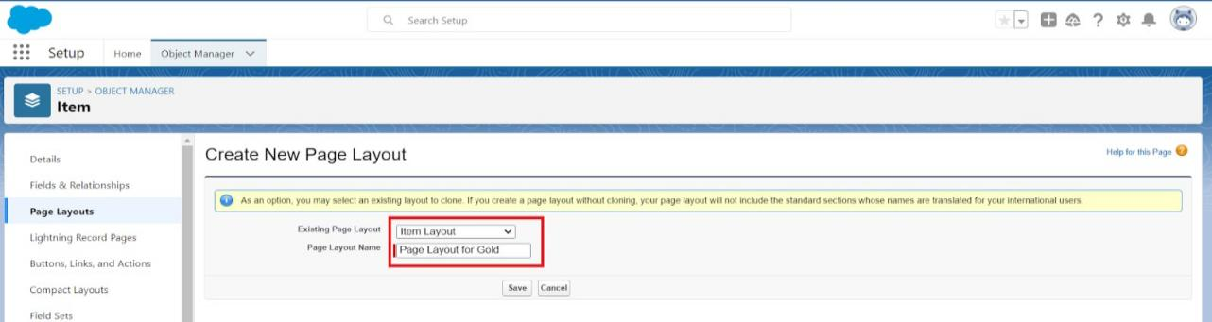GivePagelayoutNameas“PageLayoutforGold”andclickonSaveandNew.
4. ArrangethefieldasshownintheInformationSection,removefieldswhichare related to Silver and click Ok.

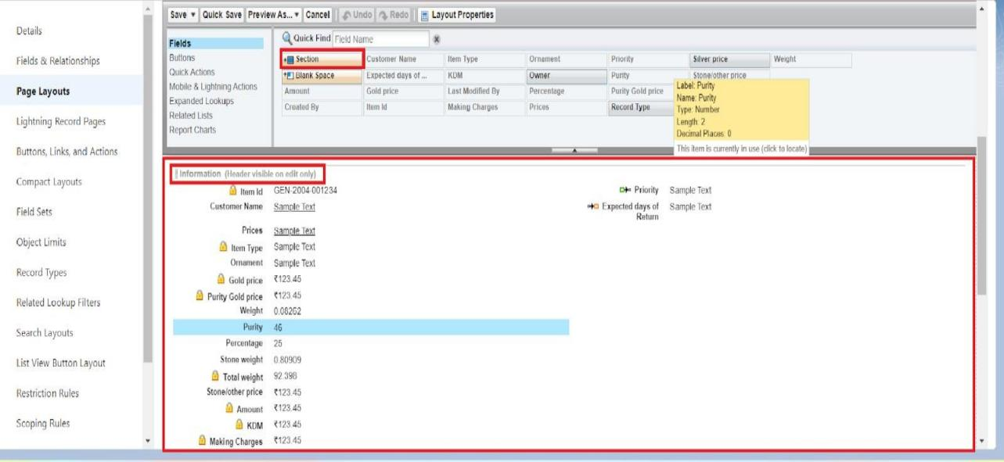

1. ClickSave.
2. Makesureyourpagelayoutlookslikethepictureabove.

**Activity2:ToCreateaSilverPagelayout**

1. GotoSetup>> ClickonObject Manager>> Searchfortheobject (Item)>>Fromdropdown click on Edit.
2. ClickonPagelayout >> ClickonNew.
3. GivePagelayout Nameas“PageLayoutforSilver”andclickonSave.
4. ArrangethefieldasshownintheInformationSection,removefieldswhichare related to Goldand click Ok.

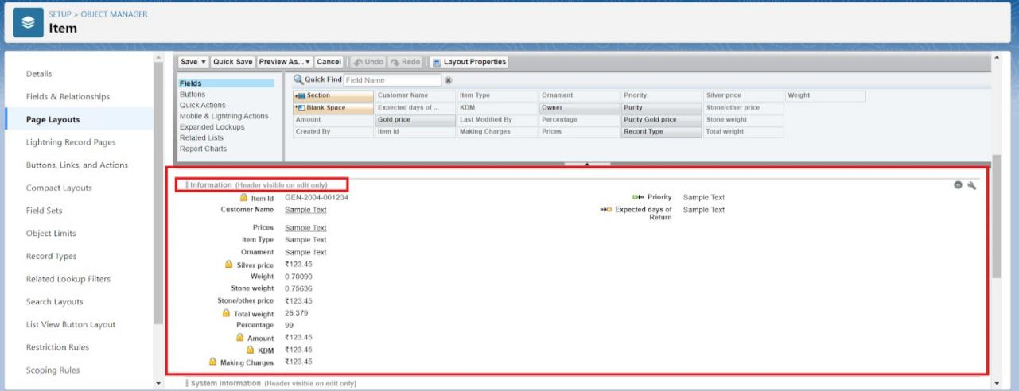

# **Milestone10:RecordTypes**

RecordTypesareawayofgroupingmanyrecordsofonetypeforthatobject.Thesecan beapplied toany standard or custom object,and allow youtohavea different page layout,fields,requiredfields,andpicklistvalues.Recordtypesallowadministratorsto createa different pagelayout withcustom picklist fields and values for thesame business process and various business processes.

### **UseCase:**

All things done for the organisation. But some of the organisations feel it difficult to fill up all the detailswhilecreatingarecord,soGoldSmithassigned youatasktocreatedifferentformsforGold and Silver records based on their mode of work. As an Admin, you know how to achieve this.

Activity1:TocreateaRecordType

1. Gotosetup>> clickonObjectManager>> typeobject name(Item)inquickfindbar?clickon the object.
2. ClickontheRecordTypes>>clickNew.

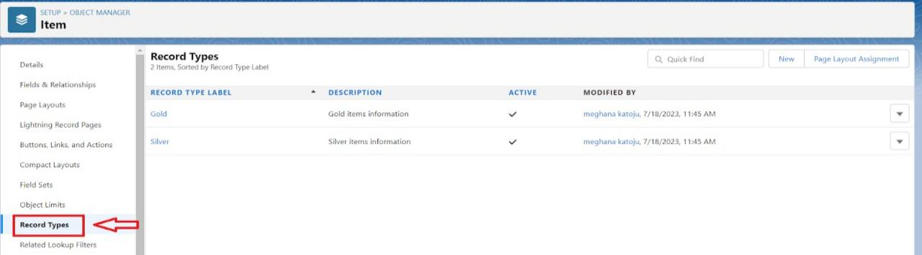

1. SelectExistingRecordas“Master”,RecordtypeLabelas“Gold”,Descriptionas“Golditems information”.

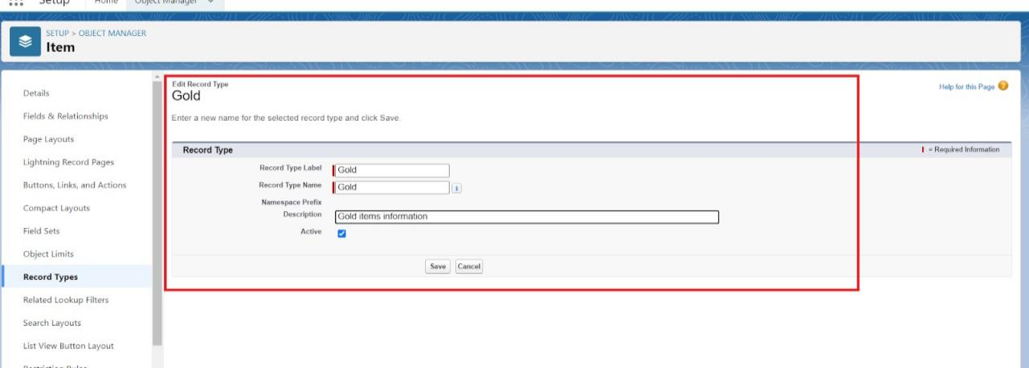

1. 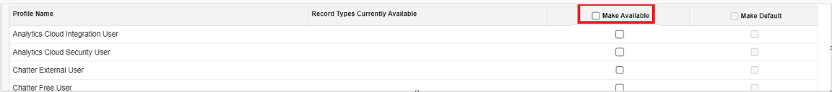Uncheckfor“MakeAvailable”.
2. ScrolldownandcheckfortheGoldSmith,WorkerJW&SystemAdministrator profile and click on Next.

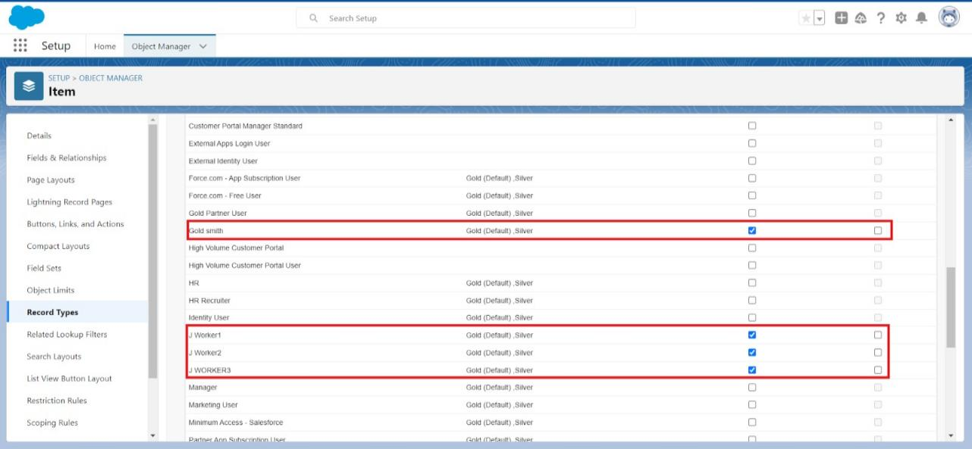

1. Select“Applyadifferentlayoutforeachprofile”,andchangepagelayoutto“Page LayoutforGold“forGoldSmith,WorkerandSystemAdministrator?save&new.

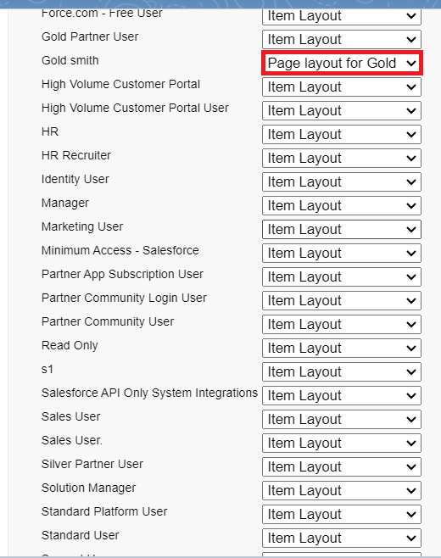

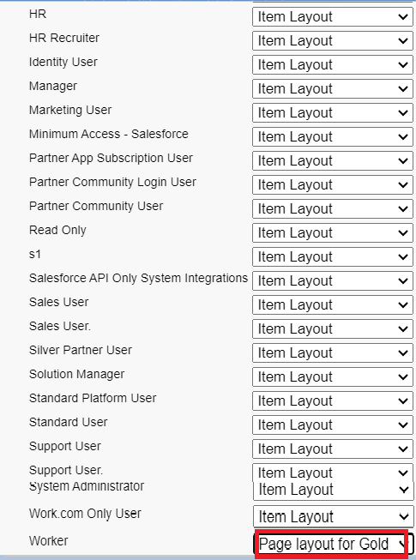

Activity2:CreateanotherRecordTypewithname“Silver”followingthestepsfrom

Activity1.

Note:UsepagelayoutforSilver.

# **Milestone11:Permissionsets**

A standard permission set consists of a group of common permissions for a particular feature associatedwithapermissionsetlicence.Usingastandardpermissionsetsavesyoutimeand facilitates administration because you don't need to create the custom permission set.

Activity1:Creatingpermissionset

A permission set is a collection of settings and permissions that give users access to various tools andfunctions.Permissionsetsextendusers'functionalaccesswithoutchangingtheirprofiles.Users can have only one profile but, depending on the Salesforce edition, they can have multiple permission sets.

1. Gotosetup>>type“permissionsets”inquicksearch >> selectpermission sets

>>New.

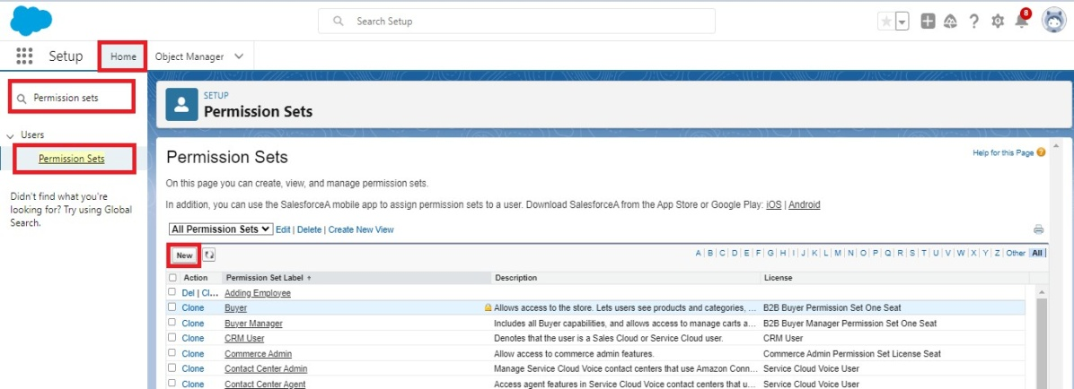

1. 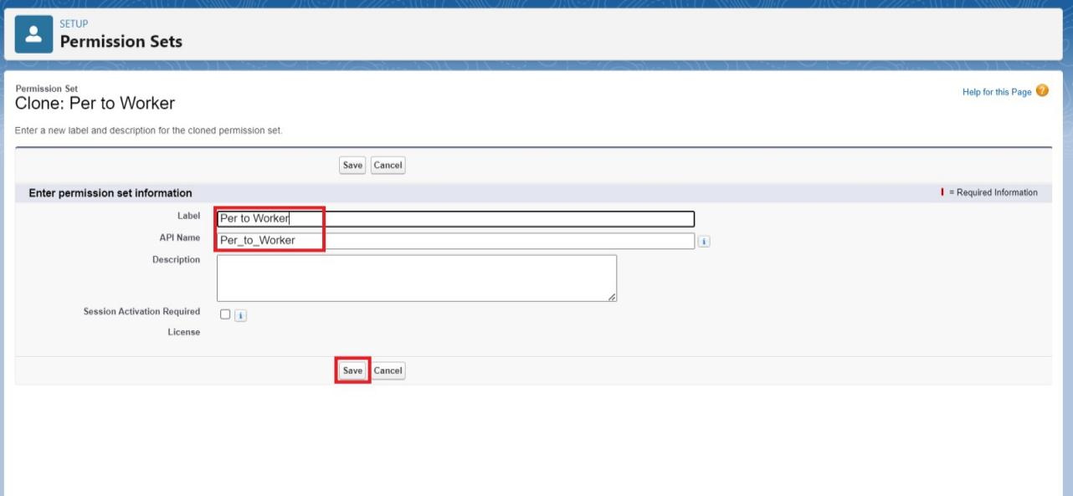Enterthelabelnameas“PertoWorker”,APIwillbeautopopulated?save.
2. UnderAppsSelectobject settings.

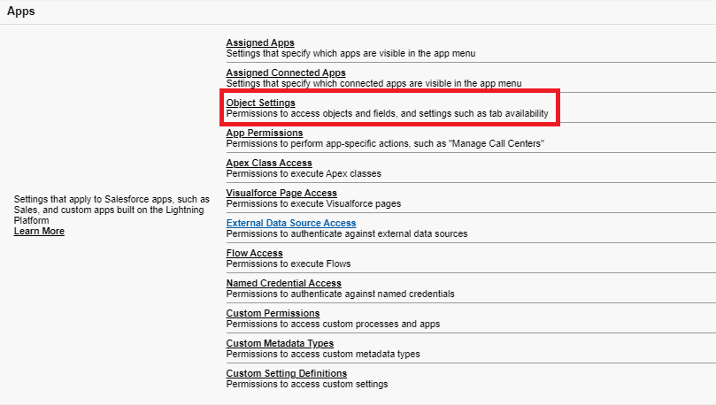

1. ClickonItemsobject?clickonEdit?underItem:RecordTypeAssignments,enableGold,Silver? Object permission check for read ,edit and create.

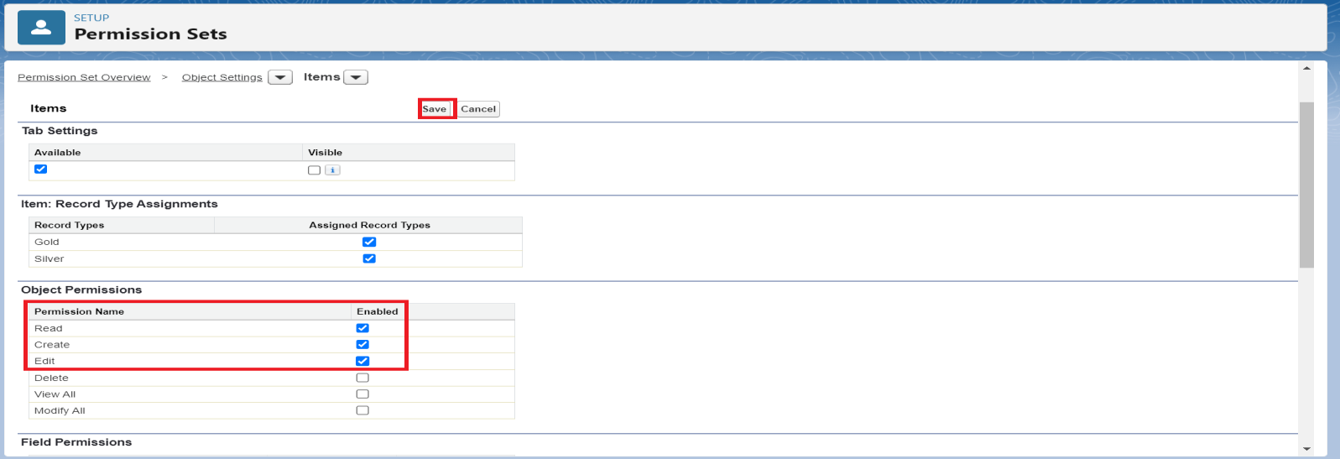

1. ClickonSave.
2. AftersavingthepermissionclickontheManageassignment
3. NowclickontheAddAssignment.

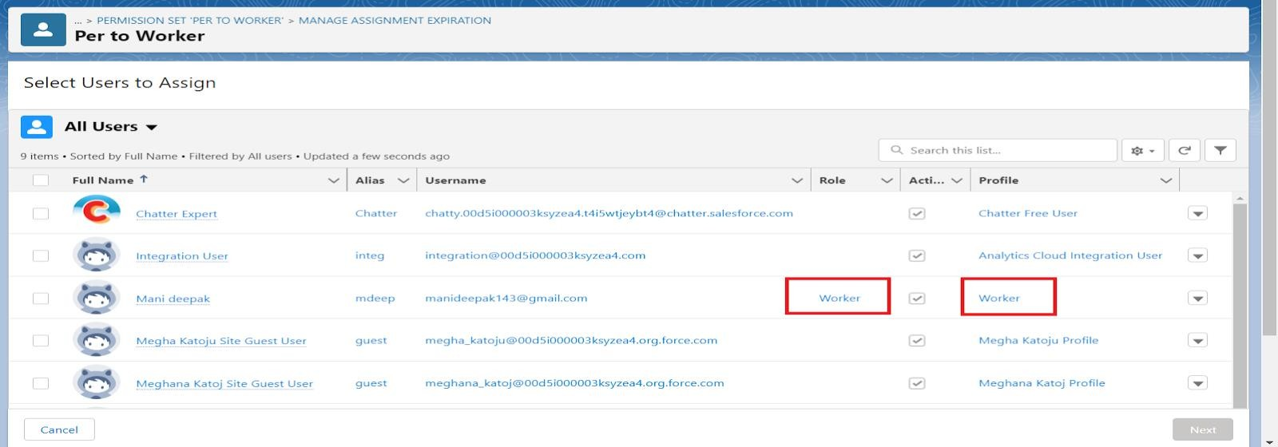

1. Nowselecttheuserswhichyouhavecreatedinusermilestone,using Worker profile and click on Next ? Assign? Done.

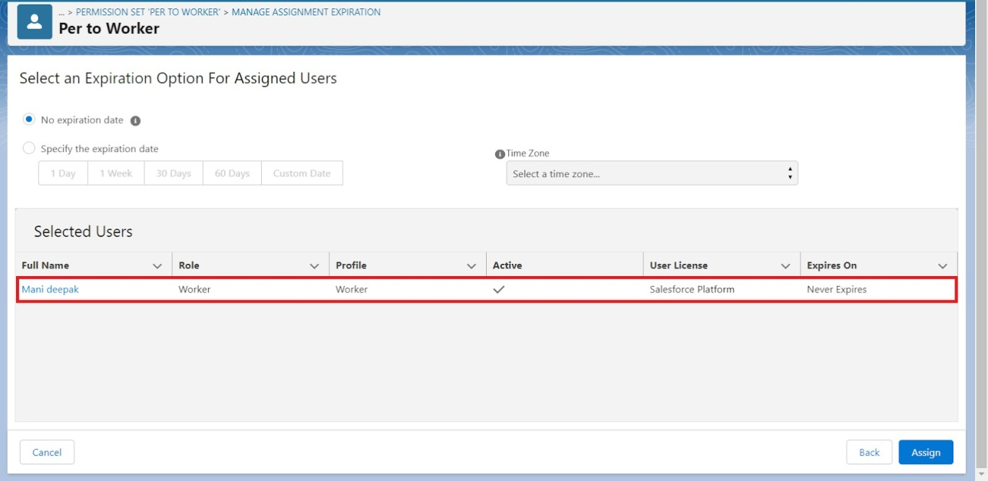

# **Milestone12:Trigger**

### **UseCase:**

Trigger and Trigger handler is designed to handle scenarios where we used to update the "Paid Amount" field on a custom object called "Billing" based on the value in a field named "Paying Amount"duringbothrecordinsertionandupdate operations.ItCalculatesandupdatesthe"Paid Amount" field based on the existing "Paid Amount" and the new "Paying Amount" during record

updates.This approachensuresthatthe"PaidAmount"accuratelyreflectsthepaymentsmadeby customers and provides a history of changes to the "Paid Amount" over time.

##### **Trigger:**

Atriggerisapieceof Apexcodethat automaticallyrunsbeforeorafterspecificevents, likerecord insertion,update,ordeletion.Triggersareusedtocustomiseandautomateactionsinresponseto these events.

Activity1:CreateaTriggerHandlerclass

##### **Triggerhandler:**

A trigger handler is a designpatternthat organises trigger logic intoseparateclasses. This helps inkeepingcodeorganised,reusable,and easiertomaintain.Thetrigger handlerclasscontainsmethodsthathandlethespecificlogicfordifferenttriggerevents, improving code structure and readability. This approach isparticularly useful for complex triggers or projects with multiple triggers, as it promotes modular coding practices and reduces the chances of code duplication.

##### **CODE:**

publicclassUpdatePaidAmountTriggerHandler{

publicstaticvoidhandleBeforeInsert(List<Billingc>newBillings){ for (Billingc billing :newBillings) {

billing.Paid_Amountc= billing.Paying_Amountc;

}

}

publicstaticvoidhandleBeforeUpdate(Map<Id,Billingc>oldBillingsMap,List<Billingc>updatedBillings) {

for(Billingcbilling:updatedBillings){

Billingc oldBilling = oldBillingsMap.get(billing.Id); DecimaloldPaidAmount=oldBilling.Paid_Amountc;

billing.Paid_Amountc= oldPaidAmount+ billing.Paying_Amountc;

}

}

}

Activity2:Createthetrigger

##### **CODE:**

triggerUpdatePaidAmountTriggeronBillingc(beforeinsert,beforeupdate){ if (Trigger.isInsert) {

UpdatePaidAmountTriggerHandler.handleBeforeInsert(Trigger.new);

} else if (Trigger.isUpdate) { UpdatePaidAmountTriggerHandler.handleBeforeUpdate(Trigger.oldMap, Trigger.new);

# **Milestone13:UserAdoption**

### **UseCase:**

As a new Administrator, you perform user management tasks like creating and editing users, resettingpasswords,grantingpermissions,configuringdataaccess,andmuchmore.Inthisunit,you will learn about users and how you add users to your Salesforce org.

Activity1:CreateaRecord(JewelCustomer)

1. ClickonAppLauncherontheleft sideof thescreen.
2. SearchJewelryInventorySystem&clickonit.

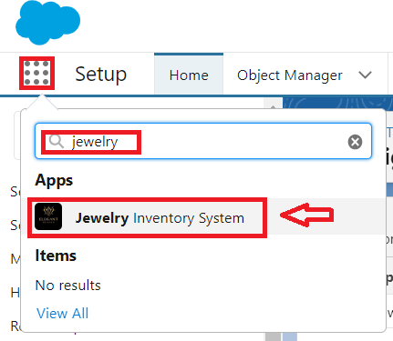

1. ClickonDropDownandClickontheJewelCustomer tab.
2. ClickNew.
3. FilltheDetailsandclickonSave.

Activity2:ViewaRecord(JewelCustomer)

1. ClickonAppLauncherontheleft sideof thescreen.
2. SearchJewelryInventorySystem&clickonit.
3. ClickontheJewelCustomerTab.
4. Clickonanyrecordname. youcanseethedetailsof theJewelCustomer.

Activity3:DeleteaRecord(JewelCustomer)

1. ClickonAppLauncherontheleft sideof thescreen.
2. SearchJewelryInventorySystem&clickonit.
3. ClickontheJewelCustomerTab.
4. ClickonArrowat right handsideonthat Particular record.
5. Clickdelete.

Note**:**Createatleast10recordsforeachoftheobjects:JewelCustomer,Price,Item,CustomerOrder and Billing.

# **Milestone14:Reports**

ReportsgiveyouaccesstoyourSalesforcedata. You canexamineyourSalesforcedatainalmost infinitecombinations,displayitineasy-to-understandformats,andsharetheresultinginsightswith others. Before building, reading, and sharing reports, review these reporting basics.

**TypesofReportsinSalesforce**

* 1. Tabular
  2. Summary
  3. Matrix
  4. JoinedReports

UseCase:

TheGoldSmithofanorganisationwantstohaveabriefdataonGoldItems,SilverItems,CustomerOrdersandBillings.Sohecanhaveaclearpictureofhisorganisation andbeabletomakeanydecisionsrequiredbasedonthisdata.Sohecallsyouonthis taskand wants youtorepresent thedata inanappropriateway.

Let’screateaReport.

**Activity1:CreateReport**

1. Gototheapp>>click on thereports tab
2. ClickNewReport.

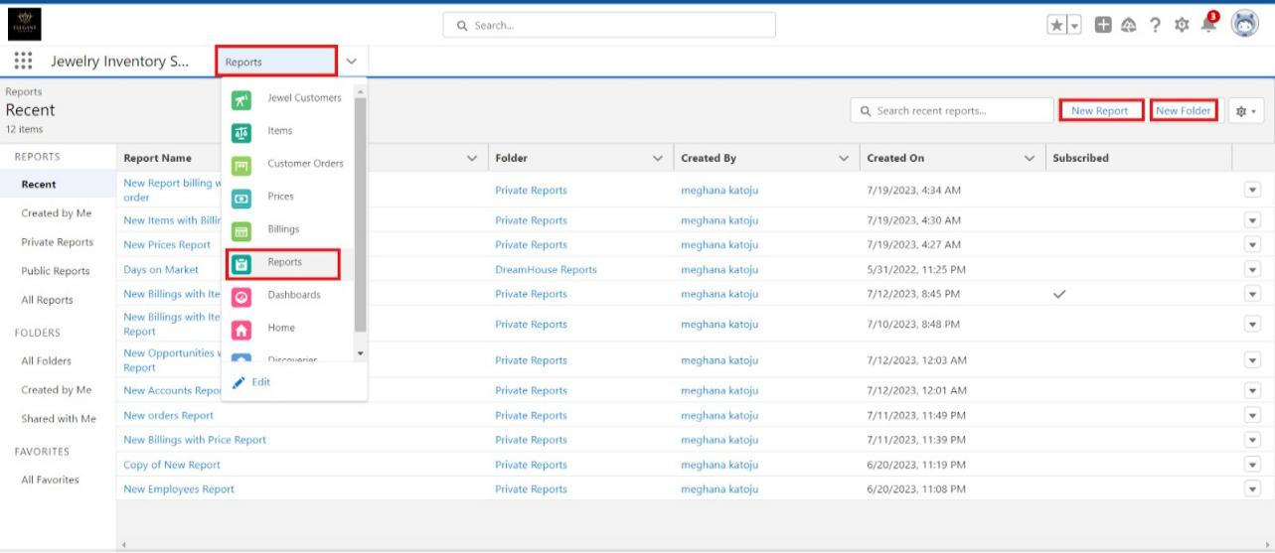

1. Selectreporttypefromcategoryorfromreporttypepanelorfromsearchpanel?clickon start report.

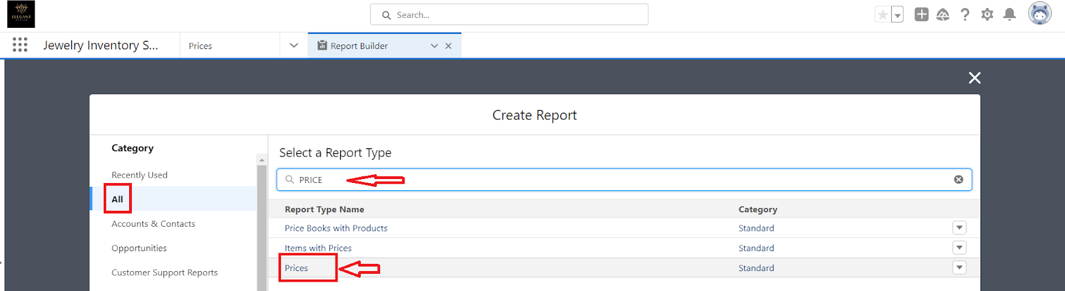

1. Customiseyourreport

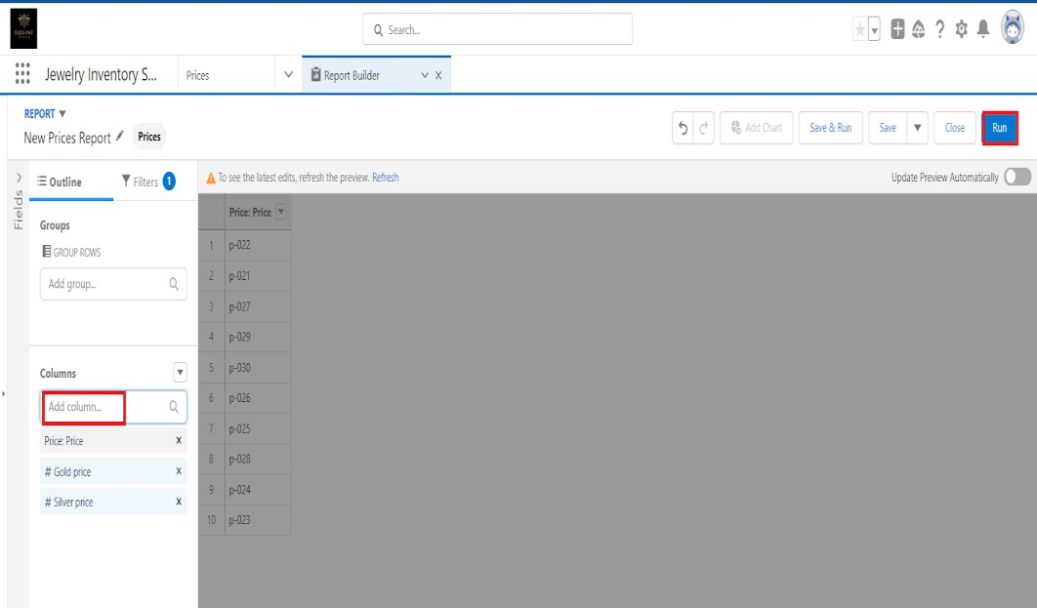

* + Addfieldsfromtheleft paneasshownbelow.

1. Saveorrunit.

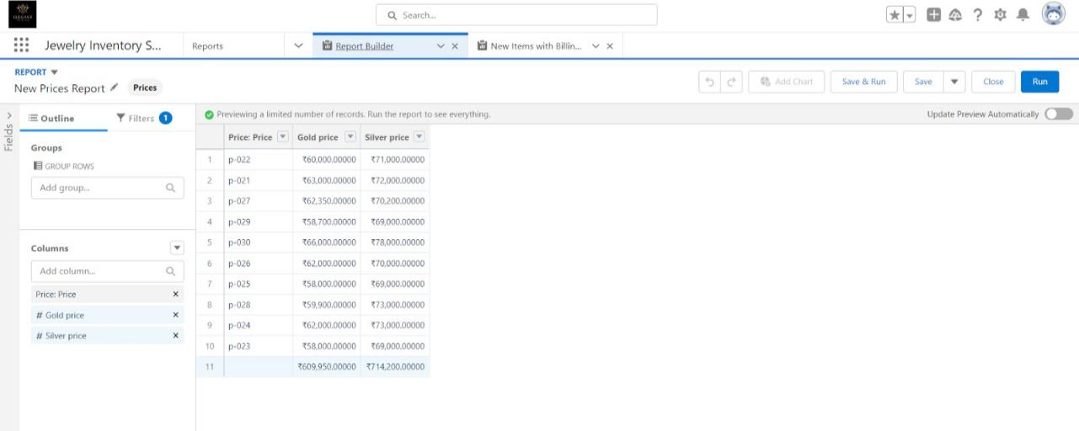

Note:Reportsmaygetvariedfromtheabovepicturesasthedatamightbedifferent.

Activity2:Reports

1. Createareport withreport type: “ItemwithBillings”.
2. Createareportwithreporttype:“BillingswithitemandCustomer order”.

# **Milestone15:Dashboards**

Dashboardshelpyouvisuallyunderstandchangingbusinessconditionssoyoucanmakedecisions based on the real-time data you’ve gathered with reports. Use dashboards to help users identify trends, sort out quantities, and measure the impact of their activities. Before building, reading, and sharing dashboards, review these dashboard basics.

##### **UseCase:**

AsanAdminfortheorganisationyoukeep pushingyourselftoreachoutthebusinessrequirements to take the organisation to peak heights and all your superiors are very much impressed with your efforts andwork dedication. Inadditionwithreports youmakeaneasefor theGoldSmithinviewing the reports with data visualisation. So he doesn't have to search for the data he wants to check.

Activity1:Dashboards

Dashboardshelpyouvisuallyunderstandchangingbusinessconditionssoyoucanmakedecisions based on the real-time data you’ve gathered with reports. Use dashboards to help users identify trends, sort out quantities, and measure the impact of their activities. Before building, reading, and sharing dashboards, review these dashboard basics.

##### **UseCase:**

AsanAdminfortheorganisationyoukeep pushingyourselftoreachoutthebusinessrequirements to take the organisation to peak heights and all your superiors are very much impressed with your efforts andwork dedication. Inadditionwithreports youmakeaneasefor theGoldSmithinviewing the reports with data visualisation. So he doesn't have to search for the data he wants to check.

# **Milestone16:Flows**

InSalesforce,aflowisapowerfultoolthatallowsyoutoautomatebusinessprocesses,collectand update data, and guide users through a series of screens or steps. Flows are built using a visual interface and can be created without any coding knowledge.

UseCase:

Flows,alsoknownasSalesforceFlowsorVisualFlows,arepowerfuldeclarativeautomationtoolsin Salesforcethat allowusers tocreateandmanagecomplex business processes without theneedfor code. Flows are designed using a drag-and-drop interface, making them easy to use for both administrators and developers. They can be used for various automation tasks like email triggers including data entry, record updates, and guided user interactions.

Activity1:CreateaFlow

1. Gotosetup>>typeFlowinquickfindbox>>ClickontheFlowandSelecttheNew Flow.

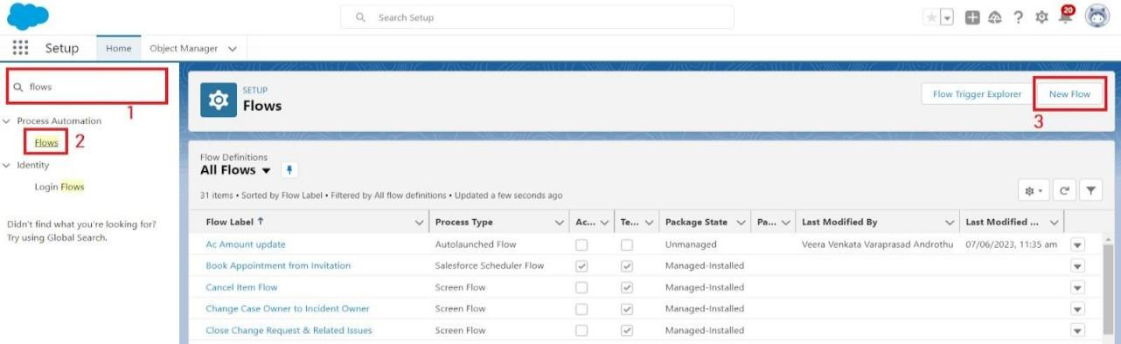

1. SelecttheRecord-triggeredflowandClickonCreate.

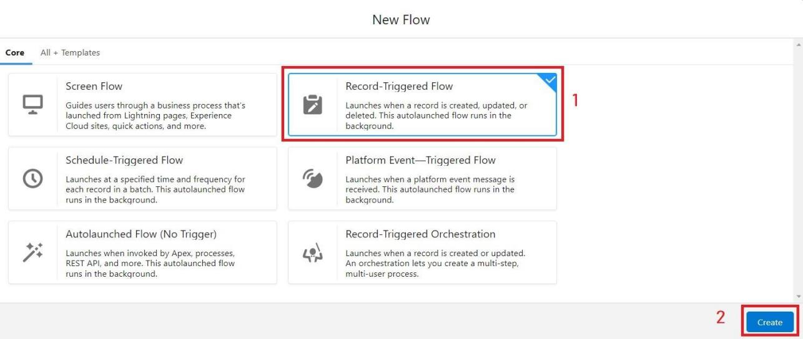

1. Select theObject asa“Billing”intheDropdownlist.
2. SelecttheTriggerFlowwhen:“ArecordisCreatedorUpdated”.
3. SelecttheOptimisetheflowfor:“ActionsandRelated Records”andClickonDone.

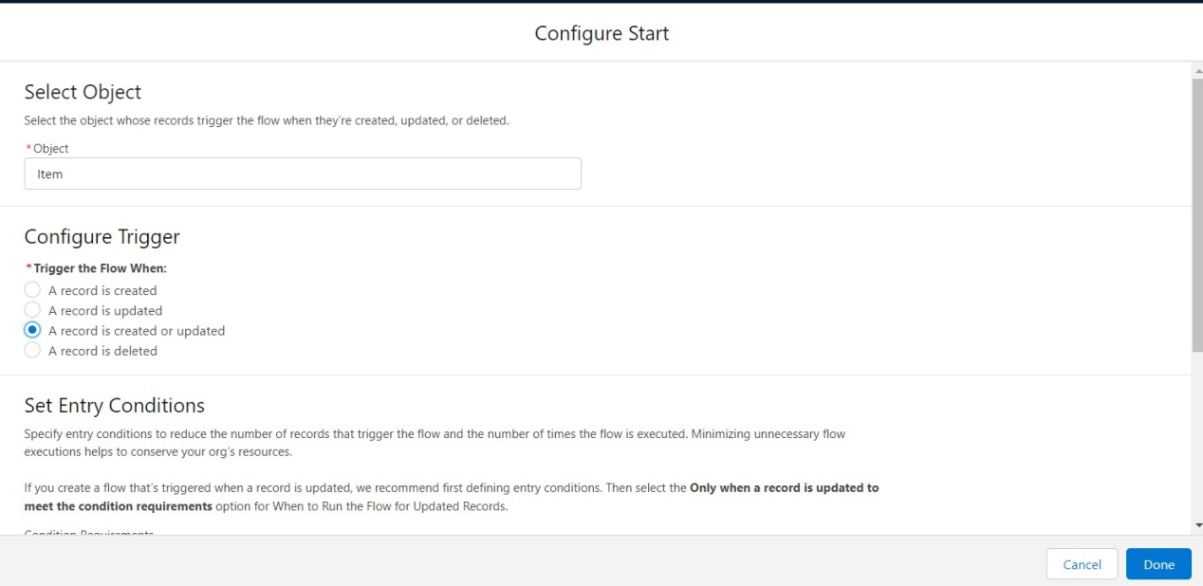

1. NowchangethemodeformAuto-layout tofree-form.
2. Nowselect themangeroptioninthetoolbox, clickNewresource.
3. Selecttheresourcetypeastext template.

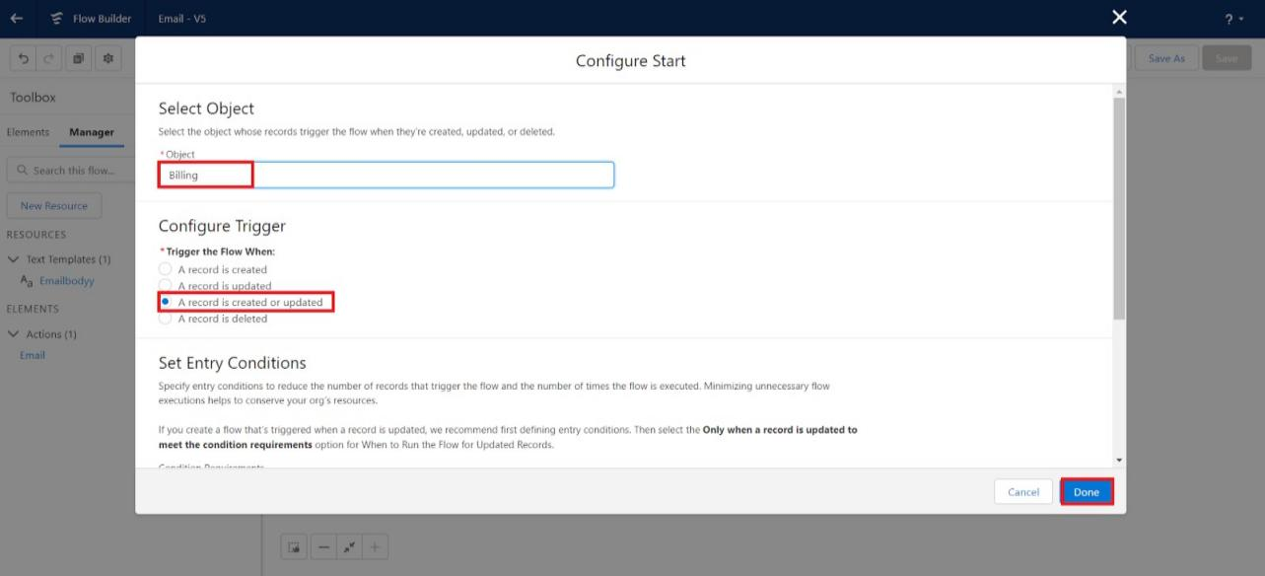

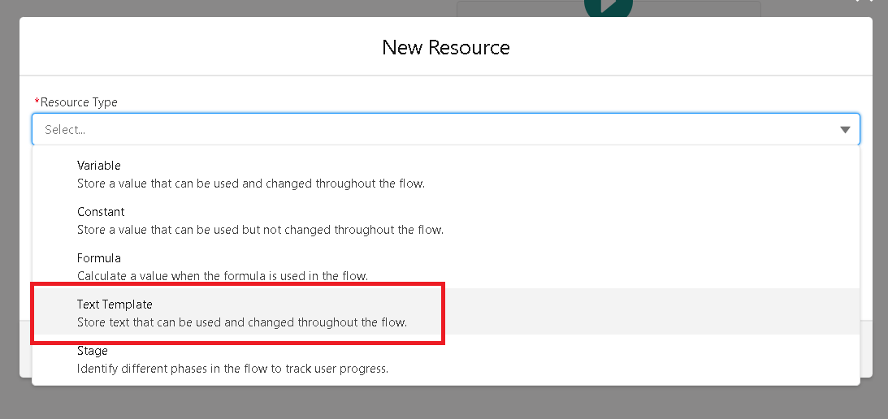

1. EntertheAPI nameas“Emailbody”.

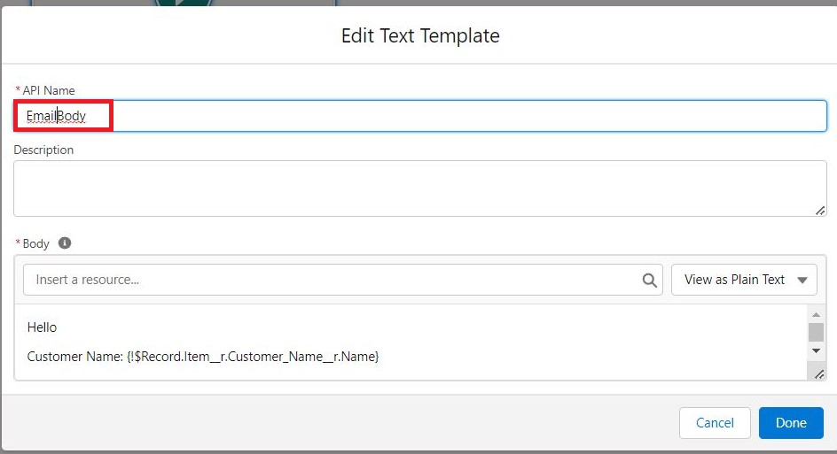

1. ChangetheviewasRichText?ViewtoPlainText.
2. Inthebodyfieldpastethesyntaxthatisgivenbelow.

Hello

CustomerName:{!$Record.Itemr.Customer_Namer.Name}

HerearethedetailsfortheitemyoupurchasedwithJewelleryInventorySystem Item Type: {!$Record.Itemr.Item_Typec}

Ornament:{!$Record.Ornamentc} Weight:{!$Record.Weightc}grams Amount: {!$Record.Amountc}

1. Clickdone.
2. Nowclickonelements,anddragtheactionelementintothepreviewpane.
3. Theiractionbarwillbeopenedinthatsearchfor“sendemail”andclickonit.
4. Givethelabelnameas“ notice”
5. APInamewillbeautopopulated.
6. Enablethebodyinset input valuesfortheselectedaction.
7. Selectthetexttemplatethatwas created.

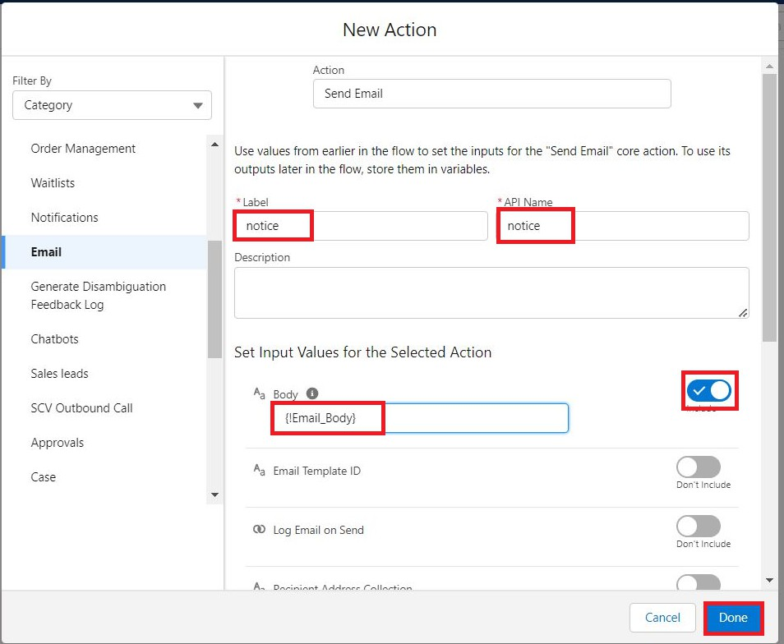

1. IncludeRecipientAddresslist,selecttheemailformtherecord. ({!$Record.Item_r.Customer_Namer.Email_c})
2. Includethesubject as“WelcometoJewelryInventorySystem”.
3. Clickdone.

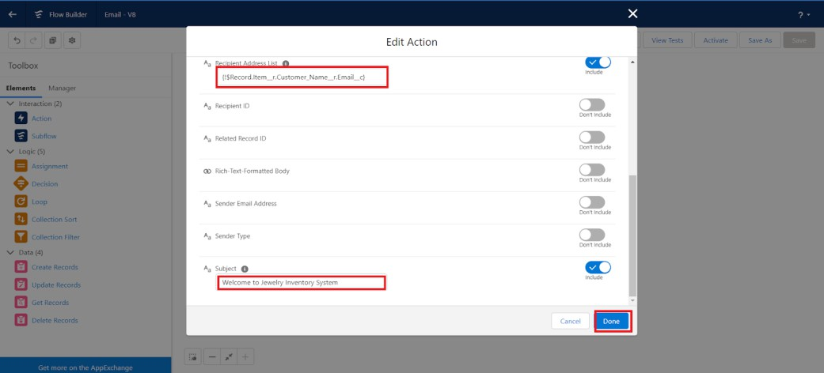

1. Nowdragthepathfromthestarttotheaction element.
2. Clickonsave.GiventheFlowlabel,FlowApinamewillbeauto populated.
3. Andclicksave, andclickonactivate.

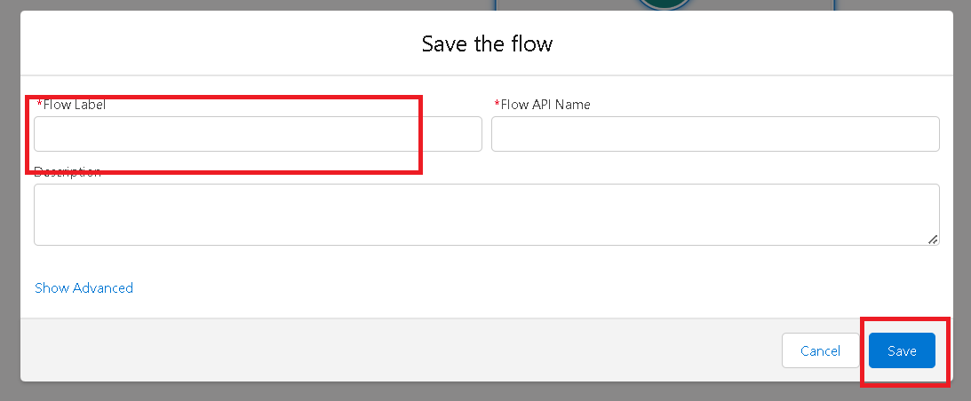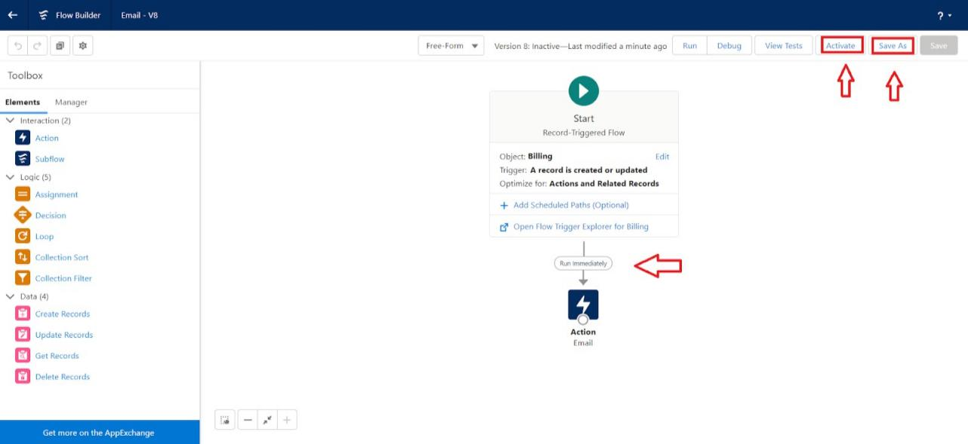

# **Milestone13:HOMEPAGE:**

UserAdoption

### **UseCase:**

As a new Administrator, you perform user management tasks like creating and editing users, resettingpasswords,grantingpermissions,configuringdataaccess,andmuchmore.Inthisunit,you will learn about users and how you add users to your Salesforce org.

Activity1:CreateaRecord(JewelCustomer)

1. ClickonAppLauncherontheleft sideof thescreen.
2. SearchJewelryInventorySystem&clickonit.



1. ClickonDropDownandClickontheJewelCustomer tab.
2. ClickNew.
3. FilltheDetailsandclickon Save.

Activity2:ViewaRecord(JewelCustomer)

1. ClickonAppLauncherontheleft sideof thescreen.
2. SearchJewelryInventorySystem&clickonit.
3. ClickontheJewelCustomerTab.
4. Clickonanyrecordname. youcanseethedetailsof theJewelCustomer.

Activity3:DeleteaRecord(JewelCustomer)

1. ClickonAppLauncherontheleft sideof thescreen.
2. SearchJewelryInventorySystem&clickonit.
3. ClickontheJewelCustomerTab.
4. ClickonArrowat right handsideonthat Particular record.
5. Clickdelete.

Note**:**Createatleast10recordsforeachoftheobjects:JewelCustomer,Price,Item,CustomerOrder and Billing.

# **Conclusion:**

The CRM Application for Jewel Management successfully demonstrates how technology can transformtraditionaljewelrybusinessoperationsintoadigital,efficient,andcustomer-focused system. The application streamlines customer management, inventory tracking, billing, and reporting, ensuring accuracy and reducing manual workload.

By integrating features like custom order management, loyalty programs, and personalized notifications, the system helps jewelers build stronger customer relationships and increase sales. Theinclusionofrole-basedsecurity,analytics,andmulti-branchsupportmakesitareliablesolution for both small jewelry shops and large chain stores.

Forstudents,thisprojectprovidedhands-onexperienceinsystemanalysis,softwaredevelopment, and real-world problem solving, while also enhancing technical skills in database design, frontend/backend development, and CRM concepts.

Inconclusion,theprojectnotonlymeetsitsobjectivesbutalsoprovesthatadomain-specificCRM solution can greatly improve business efficiency and customer satisfaction in the jewelry industry.

**ProjectAchievements:**

1. SuccessfulCRMPrototypeDevelopment –DesignedanddevelopedafunctionalCRMapplication tailored for the jewelry domain.
2. CustomerDataManagement –Implementedacentralizedsystemtostoreandmanagecustomer profiles, purchase history, and loyalty points.
3. AutomatedBilling&Invoicing–Createdabillingmodulethatgeneratesaccurateinvoiceswithtax and discount calculations.
4. InventoryTracking–Builtaninventorysystemtomanagejewelryitemsbykarat,weight,stone type, and stock availability.
5. Order&RepairHandling–Enabledsmoothmanagementofcustomorders,repairs,returns,and exchanges.
6. Reporting&Analytics–Developeddashboardstoprovidesalesinsights,customertrends,and profit analysis.
7. Role-BasedSecurity–ImplementedsecureloginandaccesscontrolforAdmin,Salesperson,and Accountant roles.
8. MarketingIntegration–Addednotificationfeatures(SMS/Email)foroffers,reminders,and customer engagement.
9. Real-WorldRelevance–Addressedactualchallengesfacedbyjewelrybusinesses,bridgingthe gap between theory and industry application.
10. Team&TechnicalGrowth–Enhancedcollaborationskillsandhands-onexperienceinfull-stack development, database design, and software engineering practices.

**StudentLearningOutcomes:**

1. UnderstandingofCRMSystems–GainedpracticalknowledgeofhowCRMapplicationsfunction in managing customer data and business operations.
2. DomainKnowledge–Learnedthespecificrequirementsofthejewelrybusinesssuchaskarat, weight, stone certification, repairs, and loyalty programs.
3. SoftwareDevelopmentSkills–Improvedtechnicalexpertiseinfrontend,backend,database design, and API integration.
4. DatabaseManagement–DesignedERdiagrams,relationalschemas,andimplementedCRUD operations effectively.
5. Problem-SolvingAbility–Appliedanalyticalskillstohandlechallengeslikeinventorytracking, billing automation, and secure user access.
6. Collaboration&Teamwork–Experiencedworkinginateamenvironment,sharingmodules,and using version control tools like GitHub.
7. ProjectLifecycleExperience–UnderstoodthestagesofSDLC(Requirementanalysis,Design, Development, Testing, Deployment).
8. Report&AnalyticsHandling–Learnedhowtogeneratesalesreports,customerinsights,and analyze data for decision-making.
9. Real-WorldApplication–Connectedacademiclearningwithreal-worldbusinessneeds,preparing for industry-ready solutions.
10. ProfessionalSkills–Enhanceddocumentation,presentation,andprojectdemonstrationskillsfor academic and professional purposes.

**FutureScope:**

1. MobileApplication–ExtendtheCRMtoAndroid/iOSplatformsforjewelersandcustomersto access on the go.
2. OnlineShoppingIntegration–ConnecttheCRMwithane-commercewebsiteforonlinejewelry sales and catalog browsing.
3. AI-PoweredRecommendations–UseAI/MLtosuggestjewelrydesignsbasedoncustomer purchase history and preferences.
4. Barcode/RFIDSupport –ImplementbarcodeorRFIDscanningforquickstockupdatesandtheft prevention.
5. PaymentGatewayIntegration–EnablesecureonlinepaymentsthroughUPI,credit/debitcards, and wallets.
6. BlockchainforCertification–Useblockchaintostoreandverifygemstone/jewelryauthenticity certificates.
7. CloudDeployment –HosttheCRMoncloudplatforms(AWS,Azure,GoogleCloud)forscalability and multi-branch usage.
8. AdvancedAnalytics–Introducepredictivesalesforecastingandcustomerchurnanalysis.
9. ChatbotSupport–AddAI-drivenchatbotsforcustomerqueries,ordertracking,andpersonalized offers.
10. Multi-LanguageSupport–Provideregionallanguagesupportforbetterusabilityacrossdifferent locations.